*Florida International University*

*School of Computing and Information Sciences*

CIS 4911 - Senior Capstone Project

Software Engineering Focus

Final Deliverable

GenomePro 2.0

Team # 6

**Team Members**

Guido Ruiz

Mardoqueu Mesquita

**Product Owner**: Michael Robinson

**Instructor**: Masoud Sadjadi

**Copyright Notice**

Copyright © 2015 by Michael Robinson. All Rights [Reserved](http://genomepro.cis.fiu.edu/medRecs/index.php).

The materials available through this document and the GenomePro website owned or provided by the here signed authors are the property of GenomePro or its licensors, and are protected by copyright, trademark and other intellectual property laws. No part of this documentation may be reproduced, distributed, or transmitted in any form or by any means, including photocopying, recording, or other electronic or mechanical methods, without the prior written permission from the authors, except in the case of brief quotations embodied in critical reviews and certain other noncommercial uses permitted by copyright law. For permission requests, write to Michael Robinson, addressed “Attention: Permissions Coordinator,” at the address: [michael.robinson@cs.fiu.edu](mailto:michael.robinson@cs.fiu.edu) .

**Trademark Notice**

**GenomePro**, the logo, and other trademarks are trademarks of Michael Robinson and may not be used without permission.

**Abstract**

The Genome Project was launched about a decade ago. After its launch, the need for new considerations on genetic aids to human diseases and the development of coherent strategies for decreasing disease phenotypes altogether was the starting point for gene hunters to start mining wonders from the human genome. These professionals needed more powerful tools and more ambitious strategies to aid their work; hence, the application of computational methods to genomic data science became an ever growing and exciting development, in both biological and medical fields of study. With these thoughts in mind, GenomePro conveys a well-structured programming framework designed to ease the development of efficient and robust analysis tools for next generation genome sequencers. These available tools provide a rich set of data access patterns that encompass the majority of data needed for genomic analysis and offer users the power to efficiently process genomic data files. It also creates results containing accurate information about the differences, similarities, and analytics between genome files.

Table of Contents

Introduction 6

Current System 6

Purpose of New System 7

User Stories 7

Project Plan 16

Hardware and Software Resources 16

Hardware: 16

Software: 16

Sprints Plan 17

Sprint 1 17

Sprint 2 19

Sprint 3 22

Sprint 4 24

Sprint 5 26

Sprint 6 28

Sprint 7 31

System Design 33

Architectural Patterns 33

Design Patterns 33

System and Subsystem Decomposition 34

Model 34

View 34

Controller 34

Class Descriptions 35

Deployment Diagram 38

System Validation 39

Glossary 49

Appendix 50

Appendix A - UML Diagrams 50

Static UML Diagrams 50

Dynamic UML Diagrams 57

Appendix B - User Interface Design 62

Appendix C - Sprint Review Reports 71

Sprint 1 Report 71

Sprint 2 Report 71

Sprint 3 Report 72

Sprint 4 Report 72

Sprint 5 Report 73

Sprint 6 Report 73

Sprint 7 Report 74

Appendix D - Sprint Retrospective Reports 75

Sprint 1 Retrospective 75

Sprint 2 Retrospective 75

Sprint 3 Retrospective 76

Sprint 4 Retrospective 76

Sprint 5 Retrospective 77

Sprint 6 Retrospective 77

Sprint 7 Retrospective 78

# Introduction

This section aims to identify and describe both the structure of the new system, in comparison with its previous version (1.0) and how it will be created and designed. This is version 2.0. We envision the system as a data processing framework designed to assist the work of many biological researchers. As such, the user interface should be simple and straightforward. The data processed by the system should always be validated and flagged as DNA, RNA, Protein, or Invalid data. Thus, GenomePro conveys a well-structured programming framework designed to ease the development of efficient and robust analysis tools for next generation genome sequencers. These available tools provide a rich set of data access patterns that encompass the majority of data needed for genomic analysis. The system is conceived at no cost for the user. This section also covers the hardware and software system requirements as well the work breakdown performed, during the 8 sprint phases of development.

# Current System

A Decade ago, the history of biology was forever transformed after an audacious decision to launch a research program that would depict, in critical detail, the complete set of genetic instructions of the human being – *The Genome Project*. The result of this development would include a new understanding of genetic contributions to human diseases and the development of coherent strategies for decreasing disease phenotypes altogether.

Not surprisingly, the disease researchers wanted to be able to analyze data as soon as possible and in the least time necessary. However, this came with some complications, as the not so small portion of discovered human genes scatters throughout the entire human genome like stars in the universe; yet, with genomic material representing light-years of noncoding DNA – *The Dark Matter*.

Gene hunters who mine wonders from the human genome need more powerful tools and more ambitious strategies. Hence, the application of computational methods to genomic data science is an ever growing and exciting development, in both biological and medical fields of study.

GenomePro helps professionals of these fields by offering unheard of specific tools and methods for sequence processing with a robust structured analysis method that leads to the predictions of undiscovered genes. This structure is thus useful for managing large volumes of data, making its representation and description more compact for better analysis and delivering a high degree of accuracy over long stretches of DNA sequence.

# Purpose of New System

The purpose of the new system is to create a web application that will be able to automate and accelerate the task of processing Gigabytes of genomic data files. The new system will offer to the users the power to efficiently process genomic data files and create result documents, which will contain accurate information about the differences, similarities, and analytics between the corresponding input files. In addition, a link to the resulted document will be emailed to the users once the system is done processing the input files. Moreover, the new system will allow the users to create and manage their account in which they can keep track of a history of jobs submitted by them and results processed by the system. The new system will also eliminate the need to manually perform these data calculations done by users, which can considerably reduce the amount of errors the users can have while doing it manually. Additionally, the new system will provide to the users the speed, performance and accuracy to make their research advance in a faster pace.

# User Stories

This section presents a list of all user stories collected during the requirement analysis for the new system. They provide a common thread that weaves through the variety of artefacts necessary to support the work in development such as project priorities and estimates, flow diagrams, touchpoint designs, user interface designs, to name a few. These user stories allowed the project team flexibility in how to respond to particular hurdles encountered during development phases; thus, permitting innovative ways for creating system value while still achieving precision on the overall project vision and priorities. These user stories are functional and prioritized as part of the project work plan to help ensure that implementation tasks were targeted at high-value activities.

**User Story # 231– Modify Existing Forgot Password Feature**

**Priority: Required**

**Description:**

* As a user, I want to login using a more intuitive way that does not obstruct other components of the website.

**User Story # 232 – Modify Existing Register Page**

**Priority: Required**

**Description:**

* As a user, I want to register in a better, more intuitive way.

**User Story # 233 – Modify Existing Login Feature**

**Priority: Required**

**Description:**

* As a user, I want to login using a more intuitive way that does not obstruct other components of the website.

**User Story # 234 – Modify Existing Submission Feature**

**Priority: Required**

**Description:**

* As a user, I want to be able to submit my sample data (in this case DNA) into the system in a secure way, so that I can use such data for other features of the site.

**User Story # 235 – Change results from Email to FTP**

**Priority: Required**

**Description:**

* As a user, I want any results of my experiments with data to be sent to me in the form of an FTP server, so that I can view the results in an effective way that has the ability to deal with very large result sets.

**User Story # 236 – Modify Existing Task Selecting Feature**

**Priority: Required**

**Description:**

* As a user, I want to be able to select which task I wish to do with my DNA, so that I can get results tailored to me and not have to pass my data through all possible tasks.

**User Story #237 – Modify Existing About Page**

**Priority: Required**

**Description:**

* As a user, I want to be able to view what GenomePro is all about in a more intuitive way than it currently is, so that I don’t have to spend too much time figuring out what functions it can offer me.

**User Story # 238 – Modify Existing Profile Page**

**Priority: Required**

**Description:**

* As a user, I want to create my profile in a more unique way, so that the GenomePro site can tailor my unique experience and so that administrators of the site know more about the kind of person who is performing tasks on DNA.

**User Story # 239 – Modify Existing Home Page**

**Priority: Required**

**Description:**

* As a user, I want the main page of GenomePro to be descriptive enough for me to understand in a nutshell, what GenomePro is about, as well as offer basic functionalities of a site, so that I am not turned down by the authenticity of the system.

**User Story # 241 – Allow PHPMYADMIN Access to Administrators**

**Priority: Required**

**Description:**

* As an administrator, I want to be able to access the PHPMyAdmin site, so that I can modify the database and monitor my users.

**User Story # 242 – Allow User Features to Administrators**

**Priority: Required**

**Description:**

* As an administrator, I want access to regular user features like uploading DNA so that I can also perform tasks on DNA.

**User Story # 243 – Modify Existing Tools Page**

**Priority: Required**

**Description:**

* As a user I want to be able to upload and delete files to/from my database so I can manage what to do with those files.

**User Story # 244 - Create File Verification Program**

**Priority: Required**

**Description:**

* As a user, I want the system to verify that my files are uploaded, so that any tools I run on them can succeed.

**User Story # 245 – Create FTP GUI Page**

**Priority: Required**

**Description:**

* As a user, I want to see my files in a user interface to view them and delete them. This includes both the files I upload and my result files. In this way I have control over what GenomePro has access to AND to view my results in an FTP page.

**User Story # 246 - Create Ubuntu Server CRON Jobs**

**Priority: Required**

**Description:**

* As a user, I want my jobs processed in a ‘first come, first serve’ order, without me being present, so that I may log in whenever I want to check the status of all the jobs I’ve submitted.

**User Story # 247 - Create Validation C Program**

**Priority: Required**

**Description:**

* As a user, I want the system to verify my uploaded files so that I know if they’re DNA, RNA, etc. or invalid.

**User Story # 248 – Modify Existing History Page**

**Priority: Required**

**Description:**

* As a user, I want to see my results listed in a table format where I can sort them by order of job id or submission date and therefore have the ability to easily search for results of my job submissions.

**User Story # 249 – Integrate Genome Signatures Functionality Tool**

**Priority: Required**

**Description:**

* As a user I want to be able to run a tool that can find differences between each genome file in order to better analyze them.

**User Story # 250 – Redesign Tools Page**

**Priority: Required**

**Description:**

* As a user I want to be able to identify all my files by type, so that I can correctly submit a job with specific requirements.

**User Story # 251 – Create Forgot Password Functionality**

**Priority: Required**

**Description:**

* As a user I want to be able to submit a “forgot password” request and receive a temporary password via email so that I may have access to my account.

**User Story # 252 – Resend Last Email Function**

**Priority: Required**

**Description:**

* As a user, if I do not receive an email from GenomePro registration and/or update email system, I should be able to have it resent to my current email. In other words, if I register, but don’t receive a confirmation email, or if I change my email and don’t receive a confirmation email, I should be able to have the GenomePro team resend me that email confirmation.

**User Story # 253 – Integrate Fasta Sub-Sequence Tool**

**Priority: Required**

**Description:**

* As a user, I want to be able to extract sub-sequences of specific lengths with my files so that I can do further studies with that information.

**User Story # 254 – Create Graphs**

**Priority: Required**

**Description:**

* As a user, I want to see my data in both numerical and graphical representation, so that I can better analyze patterns between sequences.

**User Story # 258 – Create Probes C Program**

**Priority: Required**

**Description:**

* As a user, I want to be able to get information about my map files quickly using software that can batch produce results for me, so that I can find patterns within my genome data.

**User Story # 259 – Create Unique Sequences C Program**

**Priority: Required**

**Description:**

* As a user, I want to be able to identify all unique sequences from a given map file, so that I can use that information to further develop patterns within my data.

**User Story # 260 – Create Repeated Sequences Program**

**Priority: Required**

**Description:**

* As a user, I want to be able to identify all repeated sequences from a given map file as well as its number of repeats, so that I can use that information to further develop patterns within my data.

**User Story # 261 – Organize Files by Name**

**Priority: Required**

**Description:**

* As a user, I want to see my files in both the tools page and FTP page to be sorted by time uploaded, so that I can easily navigate through them from the most recent to the oldest.

**User Story # 262 – Easier Tools Page Features**

**Priority: Required**

**Description:**

* As a user, I want to be able to see my files by double-clicking them and have map files separated from my DNA, RNA and Protein files so that I can submit jobs faster and not have to look too hard for specific files.

**User Story # 263 – Result to Upload Files**

**Priority: Required**

**Description:**

* As a user, I want to able to use some of my result files as input files for other tools, so that I don’t have to download them and upload them again.

**User Story # 264 – Media Queries For Website**

**Priority: Required**

**Description:**

* As a user, I want to be able to see the GenomePro website on different screen resolutions e.g. 1024 x 768 to 1920 x 1080 as well as on smaller mobile devices so that I can have access to my files and tools at anytime, anywhere, from the comfort of any device.

**User Story # 265 – Create GenomePro Promo Video**

**Priority: Required**

**Description:**

* As a user, I want my extracted genome file to be sorted so that I can use it with other GenomePro tools or use it with my own proprietary tools.

**User Story # 266 – Create Sort Tool**

**Priority: Required**

**Description:**

* As a user, I want to have a video that describes and promotes the tools offered by GenomePro in an easy to follow format, so that I can understand all of its features and promote GenomePro to my colleagues and friends.

**User Story # 267 – Create Maps Tool**

**Priority: Required**

**Description:**

* As a user, I want to be able to produce map files from sorted files, so that I can use the mapped data to generate charts, as well as to use them as input for other tools.

**User Story # 268 – Extend Extract Tool**

**Priority: Required**

**Description:**

* As a user, I want the extract tool to offer me different options so that I can also sort the result files it produces and/or sort and create maps from those files, and by doing this I will have no need to redo job submissions.

**User Story # 269 – Continue Adding Mobile Support**

**Priority: Required**

**Description:**

* As a user, I want to be able to have access to GenomePro using a tablet e.g. IPad, so that I can submit jobs from my mobile devices as well.

# Project Plan

This section aims to document managerial aspects of the project which are required to execute it successfully amid all possible known constrains. The organization and work breakdown is outlined here, together with the sprints that illustrate all user stories formerly implemented. The focus has been geared towards the development of a friendlier user interface and a more robust tools management interface.

## Hardware and Software Resources

### Hardware:

* ***PC - Windows OS (7+), Mac (OS X or higher), and Linux (Ubuntu)***

*Most of front end work is done in Windows platforms, and some of back end is on Linux, e.g. servers and C programs. Mac systems is used for website media*

### Software:

* ***Mingle*** *(Software development management tool, required by instructor)*
* ***GitHub*** *(Collaborative platform, required by instructor)*
* ***Google Drive*** *(Cloud storage service tool, required by instructor)*
* ***PostGreSQL*** *(Open source Object-Relational database system, required by product owner)*
* ***PHP*** *(Open source general-purpose scripting language, required by product owner)*
* ***C*** *(Programming language, required by product owner)*
* ***HTML*** *(Standard structural web pages design language)*
* ***CSS*** *(Style sheets necessary for structuring layouts of all web pages)*
* ***JavaScript*** *(Common client side scripting language to handle user interaction with web pages)*
* ***JQuery*** *(JS Library for traversal, manipulation, animation and event handling on HTML documents)*
* ***StarUML*** *(Open source Software-Modeling tool use for UML diagrams)*
* ***PHPPGADMIN*** *(UI for PostgreSQL)*
* ***Skype*** *(Collaborative source of communication in voice and video format)*
* ***Microsoft Expression Web 4.0*** *(Used for Html Site design format)*
* ***Adobe Dreamweaver CS3*** *(Used for Html Site design format and Media enhancement)*
* ***Adobe Premiere Pro CS3*** *(Used for Video Making and Editing)*
* ***Selenium IDE 2.9.0*** *(Used to automate system tests and validations)*

## Sprints Plan

During each sprint, visual artifacts were created, thus driving the team towards a spirit of work completion with the opportunity to show off new work at each sprint demo. Valid incremental feedback from stakeholders during these demos, allowed for improvement of team productivity and confidence in the product development process as a whole. Below is a brief description of each sprint, based on each implemented user story.

### Sprint 1

(08/31/2015 – 09/11/2015)

**User Story # 232 – Modify Existing Register Page**

**Tasks**

1. Redesign Database Schema.
2. Create link from home page to register page
3. User should register with a required user name and email address

**Acceptance Criteria**

1. Register page should be linked from home page
2. Should have an option to change password
3. Should validate username, email and password inputs
4. Passwords should be 7-15 characters, at least one lowercase, one uppercase and one number
5. Username must be a combination of letters and numbers with at least 3 characters

**User Story # 233 – Modify Existing Login Feature**

**Tasks**

1. Modify Login so that user logs in with username and not with email address
2. Login should be on the Home Page and be one of the first options a user sees

**Acceptance Criteria**

1. Login functionality must be present in every page.
2. Login must not obstruct other elements of the page
3. The Login functionality must be able to process sensitive data securely.
4. The Login functionality cannot, under any circumstance, “fail” and lead to a different user who is not intended.

**User Story # 237 – Modify Existing About Page**

**Tasks**

1. Modify layout of page so that users can navigate page with more information
2. Add promo video to make GenomePro more marketable

**Acceptance Criteria**

1. About page must be its own separate page.
2. About page should be visible to both logged in and guest users, as well as administrators.
3. About page should be written properly, free of grammar mistakes, and clearly visible.
4. About page should outline which tasks GenomePro can perform on DNA.

**User Story # 239 – Modify Existing Home Page**

**Tasks**

1. Modify Home Page to be more attractive and more marketable
2. Add intended audience and testimonials

**Acceptance Criteria**

1. Index page must be redesigned without the use of Bootstrap CSS.
2. Index page must have the login feature within the top right hand corner.
3. Index page must have the register feature somewhere in the site.
4. Index page must summarize “about me” page.
5. Index page must be somewhat responsive, color friendly, and sleek.
6. Index page cannot be too simple as to look bland, and cannot look too complex.

**User Story # 243 – Modify Existing Tools Page**

**Tasks**

1. Modify Tools page to give a better understanding of all tools
2. Add three sections: Tools description, Tools Management and Tools helper
3. Allow user to upload files, select tools and submit jobs
4. Add color coding to distinguish types of files

**Acceptance Criteria**

1. User can upload files and manage those files
2. User can select files from database and run tools with such files
3. User must be able to distinguish between files

### Sprint 2

(09/14/2015 – 09/25/2015)

**User Story # 236 – Modify Existing Task Selecting Feature**

**Tasks**

1. Modify the selection of tasks by adding checkboxes
2. Allow users to select multiple tasks for one job

**Acceptance Criteria**

1. Task selection must be a drop down (therefore scalable if more tasks are later created).
2. Task selection should only be visible to me if I am logged in and if I have DNA within the system.
3. I should be able to select one or more of my DNA files to be processed by such task.

**User Story # 234 – Modify Existing Job Submission Feature**

**Tasks**

1. Allow file submissions for multiple tools
2. Allow large files, e.g. 5GB
3. Send email to user when job submission is complete

**Acceptance Criteria**

1. Must be done entirely using PHP.
2. Must be efficient enough to process large files.
3. Must be able to securely handle sensitive data.
4. Must submit data into database using POSTGRES-SQL.

**User Story # 238 – Modify Existing Profile Page**

**Tasks**

1. Modify Profile Page to have a more friendly UI
2. Add number of jobs submissions by the user
3. Add table of pending jobs

**Acceptance Criteria**

1. Profile page must not show default pictures of other people.
2. Profile page must be easy to change.
3. Profile page must have functionality for changing passwords and emails.
4. Profile page must be sleek in design, and should allow the user to upload a picture.

**User Story # 244 – Create File Verification Program**

**Tasks**

1. Write C program for file validation
2. Reject empty or invalid files
3. Email user whether file is invalid or valid
4. Delete file from database if file is flagged invalid, i.e. not DNA,RNA or Protein

**Acceptance Criteria**

1. User should be notified if the file is DNA, RNA, or any other type of accepted file type.
2. Program should be efficient, in ANSI C, and should run directly from Web Server.
3. No invalid file should be uploaded to the site.
4. Site should be able to handle very large files, e.g. 1TB or more.

**User Story # 235 – Change Results from Email to FTP**

**Tasks**

1. Create FTP server
2. Store users job results in the FTP server
3. Allow user to navigate through FTP server
4. Create credentials for user

**Acceptance Criteria**

1. FTP server must be secure, and any link to such FTP server should be sent by email.
2. FTP server must ask user for credentials, presumably the same username and password used on the site.
3. FTP server must be fast and must have an up time of more than 90%.

**User Story # 241 – Allow PHPMYADMIN Access to Administrators**

**Tasks**

1. Allow admin user into PHPMYADMIN

**Acceptance Criteria**

1. Website must have a button to lead the administrator to the PHPMyAdmin site.
2. Button must only be visible to administrators.
3. A secondary login system within the PHPMyAdmin site should be present in case a misuser gains access to such button.

**User Story # 242 – Allow User Features to Administrators**

**Tasks**

1. Allow all common features from regular users to administrators

**Acceptance Criteria**

1. Administrator interface, must be similar to regular user interface.
2. All features should be visible on both types of users.

### Sprint 3

(09/28/2015 – 10/09/2015)

**User Story # 246 – Create Ubuntu Server CRON Jobs**

**Tasks**

1. Create CRON jobs in Ubuntu

**Acceptance Criteria**

1. CRON job should run every 5 minutes.
2. CRON job must be secure of any holes. It must use the database to pull all pending jobs.
3. CRON job should not halt if it has not finished within the 5 minute grace period.
4. CRON job executes PHP file that runs programs and creates results.

**User Story # 248 – Modify Existing History Page**

**Tasks**

1. Add sortable table with all results from job submissions
2. Add links to each result redirecting users to actual results

**Acceptance Criteria**

1. Must have a sortable table of results with links to each job submission
2. Results should be linked to a results page on FTP server
3. Table should not make the page grow in size, i.e. should be scrollable

**User Story # 245 – Create FTP GUI Page**

**Tasks**

1. Create interface for user interact with files and results
2. Interact interface with the FTP server

**Acceptance Criteria**

1. GUI should be simple in design and intuitive.
2. Page should not interact with the main website, A.K.A should be independent.
3. Should open up in a new tab and should be accessed from the profile page.
4. Page must have a way of removing files as well as viewing files uploaded.

**User Story # 247 – Create Validation C Program**

**Tasks**

1. Create C program for file validation

**Acceptance Criteria**

1. Must be a C program that takes as input one file.
2. Must run fast enough to handle big files like 50GB in around 5 minutes tops.
3. Must be scalable enough in case more types of files are added.

**User Story # 249 – Integrate Genome Signatures Functionality Tool**

**Tasks**

1. Integrate C program for the genome signature tools
2. Implement PHP function to generate C program arguments from user’s input

**Acceptance Criteria**

1. Must accept any number of input from user
2. Must return email to user upon job completion
3. Results should be sent to user’s history and result page.

### Sprint 4

(10/12/2015 – 10/23/2015)

**User Story # 249 – Integrate Genome Signatures Functionality Tool**

**Tasks**

1. Integrate C program for the genome signature tools
2. Implement PHP function to generate C program arguments from user’s input

**Acceptance Criteria**

1. Must accept any number of input from user
2. Must return email to user upon job completion
3. Results should be sent to user’s history and result page.

**User Story # 245 – Create FTP GUI Page**

**Tasks**

1. Create interface for user interact with files and results
2. Interact interface with the FTP server

**Acceptance Criteria**

1. GUI should be simple in design and intuitive.
2. Page should not interact with the main website, A.K.A should be independent.
3. Should open up in a new tab and should be accessed from the profile page.
4. Page must have a way of removing files as well as viewing files uploaded.

**User Story # 252 – Resend Last Email Function**

**Tasks**

1. Create PHP function for resending email to user

**Acceptance Criteria**

1. Last Email should be stored somewhere in the user table
2. An option to resend will show if user logs in with incorrect credentials or has yet to confirm.

**User Story # 250 – Redesign Tools Page**

**Tasks**

1. Redesign tools.html to be more scalable and user oriented.

**Acceptance Criteria**

1. Files should be divided into tabs: DNA, RNA, and PROTEIN.
2. No job that requires file matching type should be accepted if multiple types are selected.
3. Should be ready for users to have lots of files and submit lots of users.
4. History of completed jobs should be displayed

**User Story # 251 – Create Forgot Password Functionality**

**Tasks**

1. Create a forgot password functionality for the website

**Acceptance Criteria**

1. Functionality should be as a pop up Javascript modal function
2. New generated password should be random and sent to user’s email
3. Functionality should be located on the home page near the login button.
4. Must validate email before sending the request

### Sprint 5

(10/26/2015 – 11/06/2015)

**User Story # 245 – Create FTP GUI Page**

**Tasks**

1. Create interface for user interact with files and results
2. Interact interface with the FTP server

**Acceptance Criteria**

1. GUI should be simple in design and intuitive.
2. Page should not interact with the main website, A.K.A should be independent.
3. Should open up in a new tab and should be accessed from the profile page.
4. Page must have a way of removing files as well as viewing files uploaded.

**User Story # 252 – Resend Last Email Function**

**Tasks**

1. Create PHP function for resending email to user

**Acceptance Criteria**

1. Last email should be stored somewhere in the user table
2. An option to resend will show if user logs in with incorrect credentials or has yet to confirm.

**User Story # 253 – Integrate Extract FASTA Sub-Sequences Tool**

**Tasks**

1. Add new tool to database and integrate with web interface.
2. Create web interface to get user’s input for sub-sequences length in the tools page

**Acceptance Criteria**

1. Tool needs to accept length of the sub-sequences to be extracted – user must be asked for it.
2. Tool should be fast and able to get input from different directories and output to a designated one.
3. Should work for FASTA and FASTQ files.
4. Results should be easy to ready.

**User Story # 254 – Create Graphs**

**Tasks**

1. Research Graphical interfaces to work with very large data
2. Create C program to populate data from a mapped file
3. Create web interface for the graphs

**Acceptance Criteria**

1. Graphs should be scalable and easy to be used
2. Graphs should be able to handle large amounts of data
3. Graphs should be able to handle data from other tools.

### Sprint 6

(11/09/2015 – 11/20/2015)

**User Story # 248 – Create Probes C Program**

**Tasks**

1. Create a program in C to return probes from a map file
2. Integrate with tools page interface

**Acceptance Criteria**

1. Program must be made in C and must be fast.
2. Program must be included in the tools page and only accept map files.
3. Program should validate arguments to ensure correct output results.

**User Story # 259 – Create Unique Sequences C Program**

**Tasks**

1. Create C program to identify unique sequences from a mapped file
2. Integrate C program with tools page interface.

**Acceptance Criteria**

1. Program should be efficient and written in C
2. Program must be included in the tools page and only accept map files.
3. Program should not take only one argument for file path and print result to screen.

**User Story # 260 – Create Repeated Sequences C Progam**

**Tasks**

1. Create C program to identify repeated sequences from a mapped file
2. Integrate C program with tools page interface

**Acceptance Criteria**

1. Program should be efficient and written in C
2. Program must be included in the tools page and only accept map files.
3. Program should not take only one argument for file path and print result to screen.

**User Story # 261 – Organize Files by Name**

**Tasks**

1. Restructure FTP page to display files sorted by uploaded time

**Acceptance Criteria**

1. Files should be sorted by timestamp, most recent first to last recent.
2. Order should work for both uploads folder as well as from the tools page
3. Order should also reflect on the results page.

**User Story # 262 – Easier Tools Page Feature**

**Tasks**

1. Enable file view from select option on tools page
2. Separate map files from DNA, RNA and Protein files
3. Add field for probes

**Acceptance Criteria**

1. Files in the tools page select option should open on double-click to be viewed in a new tab.
2. Map files must be independent of DNA, RNA and Protein Files
3. Input field for probes must be multiple.

**User Story # 263 – Result to Uploads Files**

**Tasks**

1. Restructure FTP page to display files sorted by uploaded time

**Acceptance Criteria**

1. Currently only supported by files generated by Extract Fasta/FastQ tool.
2. Files created should not be copied into the results folder, but instead added to the database
3. Files should be validated before it becomes accessible by the user.
4. User should be able to delete these files

**User Story # 264 – Media Queries for Site**

**Tasks**

1. Add media queries for screen resolutions between 1024 x768 to 1920 x 1080 and for mobile devices

**Acceptance Criteria**

1. Website should be responsive for screens in the range of min-width 1024 to max-with 1920.
2. Website should be responsive for mobile devices screens e.g. min-width 320
3. Website should use some sort of column format change for smaller screen devices.

**User Story # 265 – Create GenomePro Promo Video**

**Tasks**

1. Create promo video to market GenomePro tools as well as the website features

**Acceptance Criteria**

1. This is can be a prototype video.
2. Video should be uploaded to YouTube for increase marketability
3. Order should also reflect on the results page.

### Sprint 7

(11/23/2015 – 12/04/2015)

**User Story # 266 – Create Sort Tools**

**Tasks**

1. Create a program in C to sort clean files, i.e. files that only contain DNA, RNA, or PROTEIN
2. Integrate with tools page interface

**Acceptance Criteria**

1. Program must be made in C and must be fast.
2. The result files generated by this tool should be placed as input files for other tools.

**User Story # 267 – Create Maps Tool**

**Tasks**

1. Create C program to generate maps from results of other tools
2. Integrate C program with tools page interface.

**Acceptance Criteria**

1. Program should be efficient and written in C
2. The output result should be a selection for generating charts in the chart page.

**User Story # 268 – Extend Extract Tool**

**Tasks**

1. Extend extract tool program to sort and/or map files after extraction
2. Integrate new exract program with tools page interface

**Acceptance Criteria**

1. Extension should be an option for users to choose whether to extract sorted or extract sorted and mapped.
2. The result files generated by this tool should be placed as input files for other tools.

**User Story # 269 – Continue Adding Mobile Support**

**Tasks**

1. Restructure FTP page to display files sorted by uploaded time

**Acceptance Criteria**

1. Website should be responsive on mobile devices, e.g. iPad and iPhone.
2. Website should maintain its functionality on mobile devices

# System Design

This section provides a detailed description of the design architecture and patterns used in the GenomePro application. It refers to class diagrams in Appendix A which contains a depiction of all sub-systems implemented, as well as the sequence diagrams for each use case implemented describing the object interactions. Finally this section provides a brief statement of purpose of each class.

## Architectural Patterns

As a website application, GenomePro is bound to many pre-existing conventions and technical requirements that come with developing on such a platform. Our chosen architecture is not innovative or new, but purely another adaptation of common patterns used by many of the million web applications that already exists in place. The advantage to this, is that our architecture incurs low risk in implementing, since it has already been tried and tested many times over.

The system implementation was done using the **Model – View – Controller (MVC)** as the primary architectural pattern for the GenomePro system. MVC is the basic architecture for most web applications, mainly because this platform has been designed in such a way that it forces web applications into such a setup. Nevertheless, this architecture is still appropriate for our system and we are glad to work with it, because it emphasizes modularity and scalability allowing the separation of the application’s data, logic, and user interface.

## Design Patterns

Under the MVC architecture, the system is split into 3 packages: the UI package, the Controller package, and the Data package. These packages implement 3 design patterns, as seen in the classes diagrams shown in Appendix-A. The following is a brief explanation:

**Singleton Pattern:** GenomePro uses the Singleton Design Pattern by creating classes to manage access to all data the system will have access to and the history of all job results the user has submitted.

**Facade Pattern:** Our system uses the Facade Pattern in the Controller package as a way to make the system easier to understand, use and test. One of these classes is the system_helper.php which controls every page in the UI.

**Command Pattern:** We use the Command Pattern as a way to generalize all the different web pages by using a common class called templates.php. This class implements all pages in the system, e.g. History, Contact, Home and Tools.

## System and Subsystem Decomposition

All three components: The Models being the data being manipulated, the Views comprising the user interface, and Controllers containing the business logic that manipulates Models and Views communicate with each other through clearly defined interfaces. This makes it simple to swap components, as long as new components use the same existing interfaces. For example, if we decided to switch from remote to local database in the future, we would only need switch out the “Model” component of our application. Also, if more tools are later aggregated we can simply create new templates for such tools.

### Model

The **Model Subsystem** is composed of the objects that provide the unique capabilities and information storage for the application; It contains all the rules for processing application data. In fact, this is the key sub-system that makes the application valuable. In GenomePro the classes for the Model

### View

The **View Sub-system** grants information gathered from the Model providing a way for users to interact with this data.

### Controller

The main purpose of the **Controller Sub-system** is to decouple the Model from the View. It also handles data formatting for presentation to the user.

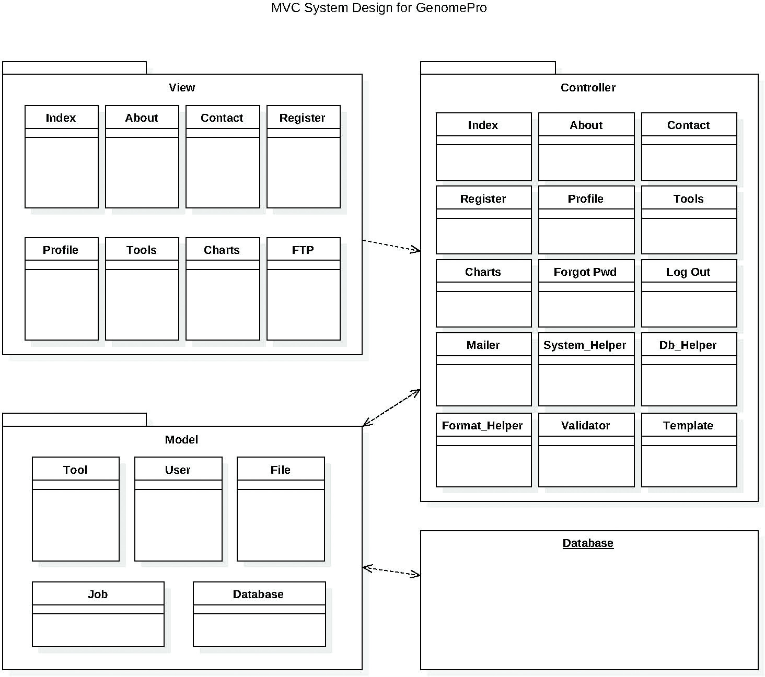

Figure Depiction of GenomePro System and Subsystem Decomposition

### Class Descriptions

To better understand the Classes Diagrams in the GenomePro system as referred in the Appendix A of this document, please see below a brief description of each class contained inside the controller and model packages of the above Class Diagram.

#### Controllers:

* ***Index Controller:*** Controls the main page of the site. Handles 'login' use cases by collecting and storing user information. Also handles 'forget password'.
* ***About Controller:*** This controller only prints out HTML data without establishing any real communication with models.
* ***Tools Controller:*** This controller collects tools, jobs, and files of a logged in user. It passes this information to the view in which the user will use to submit a job. The controller also processes such jobs.
* ***Logout Controller:*** Doesn't communicate with any views or models, but it handles the logout case. Accessed by any page, this controller simply deletes PHP sessions.
* ***Register Controller:*** Handles user registration. Doesn't send anything to any views, but collects information from the Register page. It processes the 'register' and' confirmation of email' use cases through models, mainly, the User model.
* ***Profile Controller:*** Collects user information from models, including name, jobs submitted, etc. Displays this information on the Profile view. Also handles certain use cases from the view, including 'changing password' and 'changing email'.
* ***Contact Controller:*** This controller doesn't connect to any particular model, but uses another controller – the System Helper controller, to send emails to the server. It collects information on what to write in the email by what is inputted by the user in the Contact page.
* ***System Helper Controller:*** This controller doesn't act on its own, but is used by almost all other controllers. It provides helpful features, including sending emails, uploading files to the server, uploading avatars, etc.
* ***Database Helper Controller:*** Currently unimplemented. Doesn't do anything as of now.
* ***Format Helper Controller:*** A controller used mainly by views. Its task is to format certain aspects of the website. For example, if the TIMESTAMP of a database must be converted to an easier to understand format, this controller handles such tasks.

#### Models:

* ***Database:*** Only model that connects to the database and any queries must go through here. Uses prepared statements for security, and is scalable to use with any database system.
* ***File:*** Model that handles queries with files. This model is used by any controllers that need information about a particular file, or needs to gather a series of rows from an arbitrary amount of users.
* ***Job:*** This model deals with the submission and retrieval of jobs. Used mainly by the Tools controller, this model handles queries to insert new jobs as a row in the Job table.
* ***Tool:*** A very simple model, which collects information about the kind of tools GenomePro currently offers. These are stored in the database with a name and a description, as well as a type, which signifies the kind of input the tool takes.
* **User:** The most complex model in the system. This model handles anything that is solemnly user related, including login in, logout, register, etc. As such, this model also relies on the use of queries to process information.
* ***Template:*** Although this model doesn't connect to the database, it creates a platform to allow controllers to connect with views. Using a template, a controller can assign variables, and print out the view with those variables 'baked in'.
* **Validator:** This is another model that does not connect to the database. It has the task of verifying input, including emails, passwords, etc. Used by a lot of controllers that want to validate if something is correct or not.

## Deployment Diagram

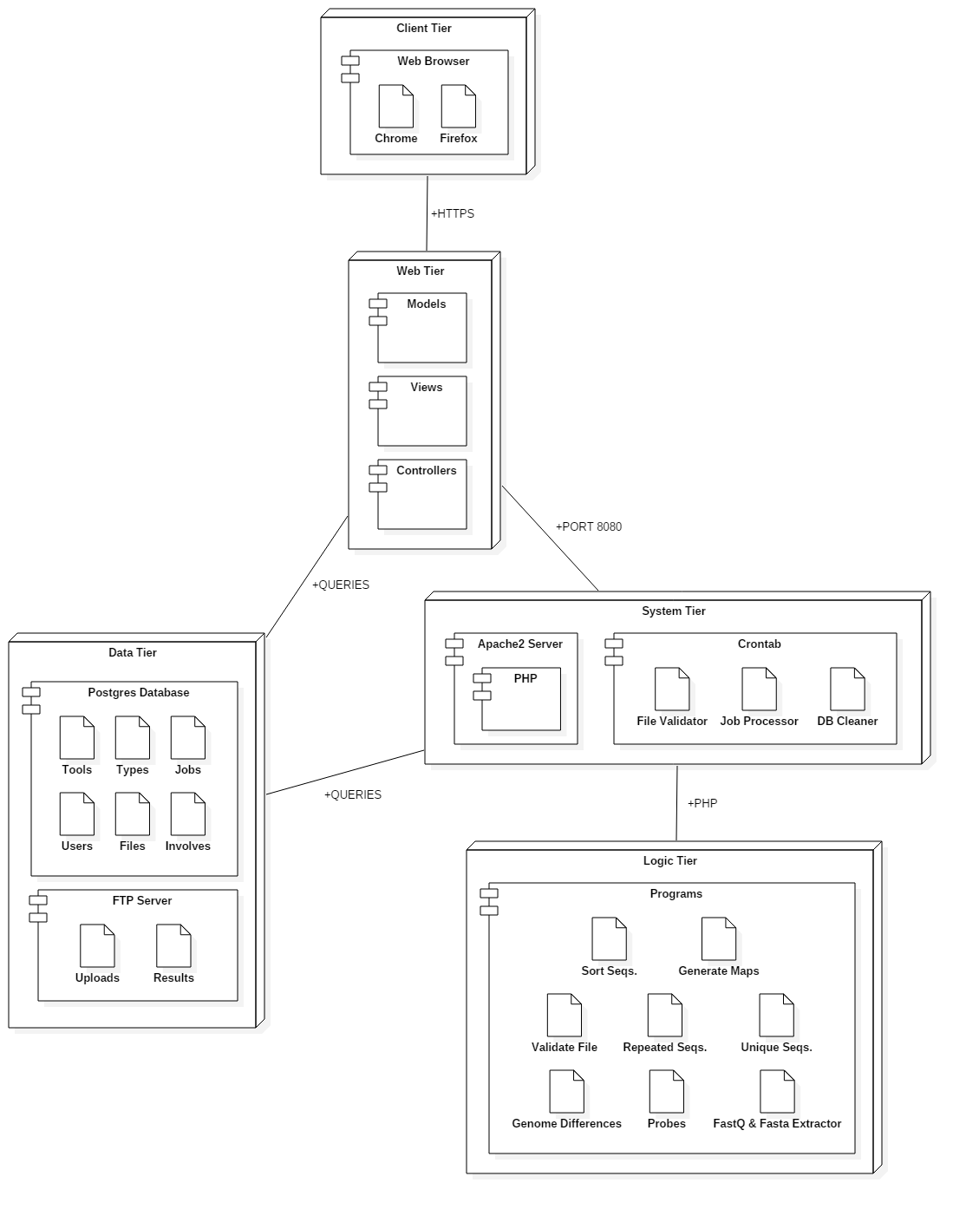

Figure - Deployment Diagram for the GenomePro Website as of Sprint 7

# System Validation

This chapter is dedicated to the testing performed on the system in order to validate and verify the functions implemented in the GenomePro system against the specified requirements. System testing was done in order to validate the system as a whole, user interface, controllers and storage. Additionally, unit testing was performed on the controller classes to test each method in these classes independently of each other method, in that class. For these purposes, the Team used Selenium IDE 2.9.0 to automate all system tests. Other manual tests were done to C programs that were created for each GenomePro 2.0 tool.

|  |  |  |  |  |  |  |  |  |  |  |  |
| --- | --- | --- | --- | --- | --- | --- | --- | --- | --- | --- | --- |
| **Test case #:** | | **001** | **Test case name:** | **Login-Sunny** | | | | | **User Story #:** | **233** | |
| **Description:** | | | Verify login feature entering correct user name and password to show successful login | | | | | | | | |
|  | | |  | |  | | |  | | | |
| **Pre-conditions:** | | | User is on home page | | | | | | | | |
|  | | |  | |  | |  | | | | |
| **Steps** | **Action** | | | | | **Value** | | | | | |
| 1 | Type user correct user name | | | | | mesq001 | | | | | |
| 2 | Type correct password | | | | | 123456 | | | | | |
| 3 | Click login button | | | | | ClickAndWait | | | | | |
| 4 | Verify Text | | | | | You have successfully logged in! | | | | | |
|  |  | | | | |  | | | | | |
|  |  | | | | |  | | | | | |
|  |  | | | | |  | | | | | |
| **Result: ✓Passed** | | | | | | | | | | | |
|  | | |  | |  | |  | | | |  |
| **Post-conditions:** | | | User is logged in, redirected to Home page and can now see all available pages to GenomePro members e.g. tools, history, profile etc. | | | | | | | | |
|  | | |  | | | | | | | | |

|  |  |  |  |  |  |  |  |  |  |  |  |
| --- | --- | --- | --- | --- | --- | --- | --- | --- | --- | --- | --- |
| **Test case #:** | | **002** | **Test case name:** | **Login-Rainy** | | | | | **User Story #:** | **233** | |
| **Description:** | | | Verify login feature entering incorrect user name and/or password to show unsuccessful login | | | | | | | | |
|  | | |  | | |  | |  | | | |
| **Pre-conditions:** | | | User is on home page | | | | | | | | |
|  | | |  | | |  |  | | | | |
| **Steps** | **Action** | | | | **Value** | | | | | | |
| 1 | Type user incorrect user name | | | | mesq002 | | | | | | |
| 2 | Type correct password | | | | 123456 | | | | | | |
| 3 | Click login button | | | | ClickAndWait | | | | | | |
| 4 | Verify Text | | | | The credentials given are incorrect. Please try again. | | | | | | |
| **Result: ✓Passed** | | | | | | | | | | | |
|  | | |  | | |  |  | | | |  |
| **Post-conditions:** | | | User is redirected to Home page, but is not logged in and a message: “The credentials given are incorrect. Please try again” is shown on the screen. | | | | | | | | |
|  | | |  | | | | | | | | |

|  |  |  |  |  |  |  |  |  |  |  |  |
| --- | --- | --- | --- | --- | --- | --- | --- | --- | --- | --- | --- |
| **Test case #:** | | **003** | **Test case name:** | **Register-Sunny** | | | | | **User Story #:** | **232** | |
| **Description:** | | | Verify register feature by entering a user name and a valid email address to show successful registration to the system | | | | | | | | |
|  | | |  | | |  | |  | | | |
| **Pre-conditions:** | | | User is on the registration page, user knows constrains for user name and password fields | | | | | | | | |
|  | | |  | | |  |  | | | | |
| **Steps** | **Action** | | | | **Value** | | | | | | |
| 1 | Type valid user name | | | | mesqma007 | | | | | | |
| 2 | Type valid email address | | | | [mesqma@mail.broward.edu](mailto:mesqma@mail.broward.edu) | | | | | | |
| 3 | Type valid password | | | | M123456m | | | | | | |
| 4 | Confirm Password | | | | M123456m | | | | | | |
| 5 | Type first name | | | | Mardoqueu | | | | | | |
| 6 | Type last name | | | | Mesquita | | | | | | |
| 7 | ClickAndWait | | | |  | | | | | | |
| 8 | VerifyText | | | | Congratulations! Please check your email to confirm your account with the system. | | | | | | |
| **Result: ✓Passed** | | | | | | | | | | | |
|  | | |  | | |  |  | | | |  |
| **Post-conditions:** | | | User is redirected to home page and a message is displayed saying: “Congratulations! Please check your email to confirm your account with the system.” | | | | | | | | |
|  | | |  | | | | | | | | |

|  |  |  |  |  |  |  |  |  |  |  |  |
| --- | --- | --- | --- | --- | --- | --- | --- | --- | --- | --- | --- |
| **Test case #:** | | **004** | **Test case name:** | **Register-Rainy** | | | | | **User Story #:** | **232** | |
| **Description:** | | | Verify register feature by entering an invalid user name and a invalid email address to show unsuccessful registration to the system | | | | | | | | |
|  | | |  | | |  | |  | | | |
| **Pre-conditions:** | | | User is on the registration page and inputs invalid user name and/or invalid email address | | | | | | | | |
|  | | |  | | |  |  | | | | |
| **Steps** | **Action** | | | | **Value** | | | | | | |
| 1 | Type invalid user name | | | | M | | | | | | |
| 2 | Type valid email address | | | | mardoqueu007@hotmail.com | | | | | | |
| 3 | Type valid password | | | | K123456k | | | | | | |
| 4 | Confirm password | | | | K123456k | | | | | | |
| 5 | Type first name | | | | Mardoqueu | | | | | | |
| 6 | Type last name | | | | Mesquita | | | | | | |
| 7 | ClickAndWait | | | |  | | | | | | |
| 8 | VerifyText | | | | Usernames must consist of letter and numbers and must have at least (3) characters | | | | | | |
| **Result: ✓Passed** | | | | | | | | | | | |
|  | | |  | | |  |  | | | |  |
| **Post-conditions:** | | | User is not registered with the system, and stays on the registration page with a message saying: “Usernames must consist of letter and numbers and must have at least (3) characters” | | | | | | | | |
|  | | |  | | | | | | | | |

|  |  |  |  |  |  |  |  |  |  |  |  |
| --- | --- | --- | --- | --- | --- | --- | --- | --- | --- | --- | --- |
| **Test case #:** | | **004** | **Test case name:** | **Contact-Sunny** | | | | | **User Story #:** | **230** | |
| **Description:** | | | Verify contact page features entering a name, a valid email address, subject and message to show successful email feature. | | | | | | | | |
|  | | |  | | |  | |  | | | |
| **Pre-conditions:** | | | User is not logged in and is on the contact page | | | | | | | | |
|  | | |  | | |  |  | | | | |
| **Steps** | **Action** | | | | **Value** | | | | | | |
| 1 | Type a name (required) | | | | Mardoqueu Mesquita | | | | | | |
| 2 | Type a valid email address (required) | | | | [mmesq001@fiu.edu](mailto:mmesq001@fiu.edu) | | | | | | |
| 3 | Type subject (required) | | | | “HELLO” | | | | | | |
| 4 | Type message(required) | | | | “I NEED HELP” | | | | | | |
| 5 | Verify Text | | | | Your message has been sent! | | | | | | |
| **Result: ✓Passed** | | | | | | | | | | | |
|  | | |  | | |  |  | | | |  |
| **Post-conditions:** | | | User receives a message saying that email was successfully sent. | | | | | | | | |
|  | | |  | | | | | | | | |

|  |  |  |  |  |  |  |  |  |  |  |  |
| --- | --- | --- | --- | --- | --- | --- | --- | --- | --- | --- | --- |
| **Test case #:** | | **004** | **Test case name:** | **Contact-Rainy** | | | | | **User Story #:** | **230** | |
| **Description:** | | | Verify contact page features entering a name, an invalid email address, subject and message to show unsuccessful email feature. | | | | | | | | |
|  | | |  | |  | | |  | | | |
| **Pre-conditions:** | | | User is not logged in and is on the contact page | | | | | | | | |
|  | | |  | |  | |  | | | | |
| **Steps** | **Action** | | | | | **Value** | | | | | |
| 1 | Type a name (required) | | | | | Michael Robinson | | | | | |
| 2 | Type an invalid email address (required) | | | | | [mmesq001fiu.edu](mailto:mmesq001@fiu.edu) | | | | | |
| 3 | Type subject (required) | | | | |  | | | | | |
| 4 | Type message(required) | | | | |  | | | | | |
| 5 | Verify Text | | | | | “The email provided was invalid, message was not sent” | | | | | |
| **Result: ✓Passed It should’ve failed** | | | | | | | | | | | |
|  | | |  | |  | |  | | | |  |
| **Post-conditions:** | | | User receives a message saying that the email provided was invalid, message was not sent | | | | | | | | |
|  | | |  | | | | | | | | |

|  |  |  |  |  |  |  |  |  |  |  |  |
| --- | --- | --- | --- | --- | --- | --- | --- | --- | --- | --- | --- |
| **Test case #:** | | **005** | **Test case name:** | **Upload-Profile-Picture-Sunny** | | | | | **User Story #:** | **238** | |
| **Description:** | | | Verify upload of profile picture by clicking on choose file button, choosing a file <= 5mb and clicking on the upload button for submission to show successful upload of selected picture. | | | | | | | | |
|  | | |  | |  | | |  | | | |
| **Pre-conditions:** | | | User is logged in and is on the profile page | | | | | | | | |
|  | | |  | |  | |  | | | | |
| **Steps** | **Action** | | | | | **Value** | | | | | |
| 1 | Click on the choose file button | | | | | Click | | | | | |
| 2 | Choose File from UI | | | | | xPath to avt.jpg | | | | | |
| 3 | Click upload button | | | | | ClickAndWait | | | | | |
| 4 | Verify Text | | | | | Your avatar was changed successfully! | | | | | |
| **Result: ✓Passed** | | | | | | | | | | | |
|  | | |  | |  | |  | | | |  |
| **Post-conditions:** | | | User receives a message saying that his/her avatar was changed successfully! | | | | | | | | |
|  | | |  | | | | | | | | |

|  |  |  |  |  |  |  |  |  |  |  |  |
| --- | --- | --- | --- | --- | --- | --- | --- | --- | --- | --- | --- |
| **Test case #:** | | **006** | **Test case name:** | **Upload-Profile-Picture-Rainy** | | | | | **User Story #:** | **238** | |
| **Description:** | | | Verify upload of profile picture by clicking on choose file button, choosing a file > 5mb and clicking on the upload button for submission to show unsuccessful upload of selected picture. | | | | | | | | |
|  | | |  | |  | | |  | | | |
| **Pre-conditions:** | | | User is logged in and is on the profile page | | | | | | | | |
|  | | |  | |  | |  | | | | |
| **Steps** | **Action** | | | | | **Value** | | | | | |
| 1 | Click on the choose file button | | | | | Click | | | | | |
| 2 | Choose File from UI | | | | | xPath to jesus.jpg | | | | | |
| 3 | Click upload button | | | | | ClickAndWait | | | | | |
| 4 | Verify Text | | | | | File exceeded maximum upload size! | | | | | |
| **Result: X Failed** | | | | | | | | | | | |
|  | | |  | |  | |  | | | |  |
| **Post-conditions:** | | | User receives a message saying that his/her chosen file exceeded maximum upload size! | | | | | | | | |
|  | | |  | | | | | | | | |

|  |  |  |  |  |  |  |  |  |  |  |  |
| --- | --- | --- | --- | --- | --- | --- | --- | --- | --- | --- | --- |
| **Test case #:** | | **007** | **Test case name:** | **Change-password-sunny** | | | | | **User Story #:** | **251** | |
| **Description:** | | | Verify changes to user’s password by entering a X-number of valid characters to show successful password update | | | | | | | | |
|  | | |  | |  | | |  | | | |
| **Pre-conditions:** | | | User is logged in and is on the profile page | | | | | | | | |
|  | | |  | |  | |  | | | | |
| **Steps** | **Action** | | | | | **Value** | | | | | |
| 1 | Click on the password field | | | | | Click | | | | | |
| 2 | Type new password | | | | | 654321 | | | | | |
| 3 | Click confirm password field | | | | | Click | | | | | |
| 4 | Type new password one more time | | | | | 654321 | | | | | |
| 5 | Click on the update button | | | | | ClickAndWait | | | | | |
| 6 | Verify Text | | | | | Your password has been changed. Please login again. | | | | | |
| **Result: ✓Passed** | | | | | | | | | | | |
|  | | |  | |  | |  | | | |  |
| **Post-conditions:** | | | User is logged out of his/her section and redirected to home page and receives a message saying: “Your password has been changed. Please login again.” | | | | | | | | |
|  | | |  | | | | | | | | |

|  |  |  |  |  |  |  |  |  |  |  |  |
| --- | --- | --- | --- | --- | --- | --- | --- | --- | --- | --- | --- |
| **Test case #:** | | **008** | **Test case name:** | **Change-password-rainy** | | | | | **User Story #:** | **251** | |
| **Description:** | | | Verify changes to user’s password by entering an invalid X-number of valid characters to show unsuccessful password update | | | | | | | | |
|  | | |  | |  | | |  | | | |
| **Pre-conditions:** | | | User is logged in and is on the profile page | | | | | | | | |
|  | | |  | |  | |  | | | | |
| **Steps** | **Action** | | | | | **Value** | | | | | |
| 1 | Click on the password field | | | | | Click | | | | | |
| 2 | Type new password | | | | | 1 | | | | | |
| 3 | Click confirm password field | | | | | Click | | | | | |
| 4 | Type new password one more time | | | | | 1 | | | | | |
| 5 | Click on the update button | | | | | ClickAndWait | | | | | |
| 6 | Verify Text | | | | | Your password has been changed. Please login again. | | | | | |
| **Result: ✓Passed : It should’ve failed** | | | | | | | | | | | |
|  | | |  | |  | |  | | | |  |
| **Post-conditions:** | | | User is logged out of his/her section and redirected to home page and receives a message saying: “Your password has been changed. Please login again.” | | | | | | | | |
|  | | |  | | | | | | | | |

|  |  |  |  |  |  |  |  |  |  |  |  |
| --- | --- | --- | --- | --- | --- | --- | --- | --- | --- | --- | --- |
| **Test case #:** | | **009** | **Test case name:** | **Change-password-sunny** | | | | | **User Story #:** | **251** | |
| **Description:** | | | Verify changes to user’s password by entering a X-number of valid characters to in the password field, but entering different characters in the conform password filed to show unsuccessful password update | | | | | | | | |
|  | | |  | |  | | |  | | | |
| **Pre-conditions:** | | | User is logged in and is on the profile page | | | | | | | | |
|  | | |  | |  | |  | | | | |
| **Steps** | **Action** | | | | | **Value** | | | | | |
| 1 | Click on the password field | | | | | Click | | | | | |
| 2 | Type new password | | | | | 654321 | | | | | |
| 3 | Click confirm password field | | | | | Click | | | | | |
| 4 | Type new password one more time | | | | | 123456 | | | | | |
| 5 | Click on the update button | | | | | ClickAndWait | | | | | |
| 6 | Verify Text | | | | | Passwords Don’t Match | | | | | |
| **Result: ✓Passed** | | | | | | | | | | | |
|  | | |  | |  | |  | | | |  |
| **Post-conditions:** | | | User receives a message saying: “Passwords Don’t Match.” | | | | | | | | |
|  | | |  | | | | | | | | |

|  |  |  |  |  |  |  |  |  |  |  |  |
| --- | --- | --- | --- | --- | --- | --- | --- | --- | --- | --- | --- |
| **Test case #:** | | **010** | **Test case name:** | **Change-email-sunny** | | | | | **User Story #:** | **238** | |
| **Description:** | | | Verify changes to user’s email address by entering a valid email address non-existent on database, i.e. not being used by some other user in the database. | | | | | | | | |
|  | | |  | |  | | |  | | | |
| **Pre-conditions:** | | | User is logged in and is on the profile page | | | | | | | | |
|  | | |  | |  | |  | | | | |
| **Steps** | **Action** | | | | | **Value** | | | | | |
| 1 | Click on the email field | | | | | Click | | | | | |
| 2 | Type new and valid email address | | | | | mesqma@mail.broward.edu | | | | | |
| 3 | Click on the update button | | | | | ClickAndWait | | | | | |
| 4 | Verify Text | | | | | Your email has been changed successfully. Please confirm it through your new email. | | | | | |
| **Result: ✓Passed** | | | | | | | | | | | |
|  | | |  | |  | |  | | | |  |
| **Post-conditions:** | | | User is logged out of his/her section, redirected to home page and receives a message saying: “Your email has been changed successfully. Please confirm it through your new email.” User cannot log in again before email confirmation. | | | | | | | | |
|  | | |  | | | | | | | | |

|  |  |  |  |  |  |  |  |  |  |  |  |
| --- | --- | --- | --- | --- | --- | --- | --- | --- | --- | --- | --- |
| **Test case #:** | | **011** | **Test case name:** | **Change-email-rainy** | | | | | **User Story #:** | **238** | |
| **Description:** | | | Verify changes to user’s email address by entering a valid email address but already existent on database, i.e. being used by some other user in the database. | | | | | | | | |
|  | | |  | |  | | |  | | | |
| **Pre-conditions:** | | | User is logged in and is on the tools page | | | | | | | | |
|  | | |  | |  | |  | | | | |
| **Steps** | **Action** | | | | | **Value** | | | | | |
| 1 | Click on the email field | | | | | Click | | | | | |
| 2 | Type new and valid email address | | | | | mardoqueu007@hotmail.com | | | | | |
| 3 | Click on the update button | | | | | ClickAndWait | | | | | |
| 4 | Verify Text | | | | | That email is already registered. | | | | | |
| **Result: ✓Passed** | | | | | | | | | | | |
|  | | |  | |  | |  | | | |  |
| **Post-conditions:** | | | User receives a message saying: “That email is already registered.” | | | | | | | | |
|  | | |  | | | | | | | | |

|  |  |  |  |  |  |  |  |  |  |  |  |
| --- | --- | --- | --- | --- | --- | --- | --- | --- | --- | --- | --- |
| **Test case #:** | | **012** | **Test case name:** | **Upload-file-sunny** | | | | | **User Story #:** | **236** | |
| **Description:** | | | Verify file upload feature by entering a file in valid format, e.g. : (.txt), (.fa), (.dna), (.gbk) etc… to show successful file upload to database | | | | | | | | |
|  | | |  | |  | | |  | | | |
| **Pre-conditions:** | | | User is logged in and is on the tools page | | | | | | | | |
|  | | |  | |  | |  | | | | |
| **Steps** | **Action** | | | | | **Value** | | | | | |
| 1 | Click on the choose file button | | | | | Click | | | | | |
| 2 | Browse file path and click ok | | | | | xPath\\test.txt | | | | | |
| 3 | Click on the upload button | | | | | ClickAndWait | | | | | |
| 4 | AssertElementPresent | | | | | Target: css=div.alert.alert-success:contains('was uploaded successfully!') | | | | | |
| **Result: ✓Passed** | | | | | | | | | | | |
|  | | |  | |  | |  | | | |  |
| **Post-conditions:** | | | User receives a message saying: “Your file ‘time-stamp’_test.txt' was uploaded successfully!” and file is uploaded to the database | | | | | | | | |
|  | | |  | | | | | | | | |

|  |  |  |  |  |  |  |  |  |  |  |  |
| --- | --- | --- | --- | --- | --- | --- | --- | --- | --- | --- | --- |
| **Test case #:** | | **013** | **Test case name:** | **Upload-file-rainy** | | | | | **User Story #:** | **236** | |
| **Description:** | | | Verify file upload feature by entering an invalid file format , e.g. : (.pdf), (.docx), etc… to show unsuccessful file upload to database | | | | | | | | |
|  | | |  | |  | | |  | | | |
| **Pre-conditions:** | | | User is logged in and is on the tools page | | | | | | | | |
|  | | |  | |  | |  | | | | |
| **Steps** | **Action** | | | | | **Value** | | | | | |
| 1 | Click on the choose file button | | | | | Click | | | | | |
| 2 | Browse file path and click ok | | | | | xPath\\test.docx | | | | | |
| 3 | Click on the upload button | | | | | ClickAndWait | | | | | |
| 4 | AssertElementPresent | | | | | Target: css=div.alert.alert-success:contains(‘Unsuported filetype detected') | | | | | |
| **Result: ✓Passed** | | | | | | | | | | | |
|  | | |  | |  | |  | | | |  |
| **Post-conditions:** | | | User receives a message saying: “All files were successfully uploaded.” and all files are shown on screen and uploaded. | | | | | | | | |
|  | | |  | | | | | | | | |

|  |  |  |  |  |  |  |  |  |  |  |  |
| --- | --- | --- | --- | --- | --- | --- | --- | --- | --- | --- | --- |
| **Test case #:** | | **014** | **Test case name:** | **Submit-job-single-genome-data-type-sunny** | | | | | **User Story #:** | **234** | |
| **Description:** | | | Verify submission of job for genome data types | | | | | | | | |
|  | | |  | |  | | |  | | | |
| **Pre-conditions:** | | | User is logged in and is on the tools page | | | | | | | | |
|  | | |  | |  | |  | | | | |
| **Steps** | **Action** | | | | | **Value** | | | | | |
| 1 | Click on the email field | | | | | Click | | | | | |
| 2 | Click | | | | | Target: xpath=(//input[@name='tools[]'])[2] | | | | | |
| 3 | addSelection | | | | | label=1444057668_test.fa.txt | | | | | |
| 4 | clickAndWait | | | | | Name=do_job | | | | | |
| 5 | assertElementPresent | | | | | Target: css=div.alert.alert-info:contains('SUCCESS:') | | | | | |
| 6 | assertElementPresent | | | | | Target: css=div.alert.alert-info:contains('_test.fa.txt') | | | | | |
| 7 | assertElementPresent | | | | | Target: css=div.alert.alert-info:contains('Genome Data Type') | | | | | |
| 8 | clickAndWait | | | | | link=profile | | | | | |
| **Result: ✓Passed** | | | | | | | | | | | |
|  | | |  | |  | |  | | | |  |
| **Post-conditions:** | | | User receives a message saying: “SUCCESS: Job [ job# ] using Tool [ Genome Data Type ] on File [ ‘time-stamp’_test.fa.txt ]”, and job is sent to be processed by the server and appended to pending jobs on user’s profile page | | | | | | | | |
|  | | |  | | | | | | | | |

|  |  |  |  |  |  |  |  |  |  |  |  |
| --- | --- | --- | --- | --- | --- | --- | --- | --- | --- | --- | --- |
| **Test case #:** | | **015** | **Test case name:** | **Submit-job-single-genome-data-type-rainy** | | | | | **User Story #:** | **234** | |
| **Description:** | | | Verify submission of job for genome data types | | | | | | | | |
|  | | |  | |  | | |  | | | |
| **Pre-conditions:** | | | User is logged in and is on the tools page | | | | | | | | |
|  | | |  | |  | |  | | | | |
| **Steps** | **Action** | | | | | **Value** | | | | | |
| 1 | Click on the email field | | | | | Click | | | | | |
| 2 | Click | | | | | Target: xpath=(//input[@name='tools[]'])[2] | | | | | |
| 3 | clickAndWait | | | | | Name=do_job | | | | | |
| 2 | assertElementPresent | | | | | Target: css=div.alert.alert-info:contains('SUCCESS:') | | | | | |
| **Result: : ✓Passed** | | | | | | | | | | | |
|  | | |  | |  | |  | | | |  |
| **Post-conditions:** | | | User receives a message saying: “You didn't select any files!” | | | | | | | | |
|  | | |  | | | | | | | | |

|  |  |  |  |  |  |  |  |  |  |  |  |
| --- | --- | --- | --- | --- | --- | --- | --- | --- | --- | --- | --- |
| **Test case #:** | | **016** | **Test case name:** | **Submit-job-multiple-genome-data-type-sunny** | | | | | **User Story #:** | **234** | |
| **Description:** | | | Verify submission of job for genome data types by checking the genome data type checkbox; selecting multiple files and clicking on the submit button to show successful jobs submissions. | | | | | | | | |
|  | | |  | |  | | |  | | | |
| **Pre-conditions:** | | | User is logged in and is on the tools page | | | | | | | | |
|  | | |  | |  | |  | | | | |
| **Steps** | **Action** | | | | | **Value** | | | | | |
| 1 | Click on the email field | | | | | Click | | | | | |
| 2 | Click | | | | | Target: xpath=(//input[@name='tools[]'])[2] | | | | | |
| 3 | addSelection | | | | | label=’time-stamp’_test.fa.txt | | | | | |
| 4 | addSelection | | | | | label=’time-stamp’_test.fa.txt | | | | | |
| 5 | clickAndWait | | | | | Name=do_job | | | | | |
| 6 | assertElementPresent | | | | | Target: css=div.alert.alert-info:contains('SUCCESS:') | | | | | |
| 7 | assertElementPresent | | | | | Target: css=div.alert.alert-info:contains('_test.fa.txt') | | | | | |
| 8 | assertElementPresent | | | | | Target: css=div.alert.alert-info:contains('Genome Data Type') | | | | | |
| 9 | assertElementPresent | | | | | Target: css=div.alert.alert-info:contains('SUCCESS:') | | | | | |
| 10 | assertElementPresent | | | | | Target: css=div.alert.alert-info:contains('_log.txt') | | | | | |
| 11 | assertElementPresent | | | | | Target: css=div.alert.alert-info:contains('Genome Data Type') | | | | | |
| **Result: ✓Passed** | | | | | | | | | | | |
|  | | |  | |  | |  | | | |  |
| **Post-conditions:** | | | User receives a message with all successful jobs being sent to the server | | | | | | | | |
|  | | |  | | | | | | | | |

# Glossary

|  |  |
| --- | --- |
| **CLASS DIAGRAM** | Describes the system in terms of *classes*, *attributes*, *operations,* and their relationships. |
| **CRON** | Linux Utility that schedules a command or script on a server to run automatically on a specified time and data. |
| **DARK MATTER** | Metaphoric term for genetic material that are unclassified or poorly understood. |
| **FASTA** | File type extension given to genomic data. |
| **FASTQ** | File type extension given to genomic data. |
| **GENOME SIGNATURES** | A tool that works on genomes to provide the differences among different genome files. |
| **JOB** | The process of submitting files as input for tools with the expectation of getting specific result files. |
| **MAP** | An ordered list of repeated sub-sequences extracted from a genome file. |
| **MODEL** | Abstraction of the reality. |
| **MEDIA QUERY** | CSS module allowing content rendering to adapt to conditions such as screen resolution (e.g. smartphone screen vs. computer screen). |
| **SEQUENCER** | A Professional in the biomedical research field that closely works with genome sequences. |
| **SEQUENCE DIAGRAM** | A sequence diagram is an interaction diagram that emphasizes the time ordering of events and messages. |
| **SERVER** | A server is a system containing both hardware and software that can provide services to the client machines, such as file access, printing, archiving, or database access. |
| **PROBE** | A sub-sequence extracted from a genome sequence. |
| **USER** | External entity that interact with the system. |
| **USER INTERFACE** | The way through which a user interacts with the computer system. |
| **VALIDATOR** | Term used to define a program that validates the integrity of a genome file and displays its data type, e.g. DNA, RNA or Protein. |

# Appendix

## Appendix A - UML Diagrams

### Static UML Diagrams

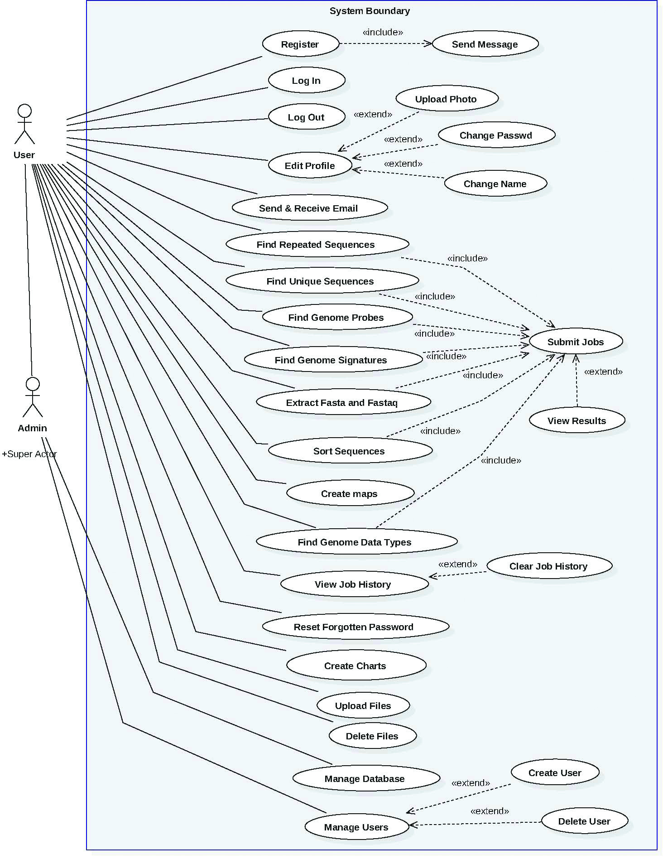

Figure - Use Cases Diagram

#### *Database Modeling Diagram*

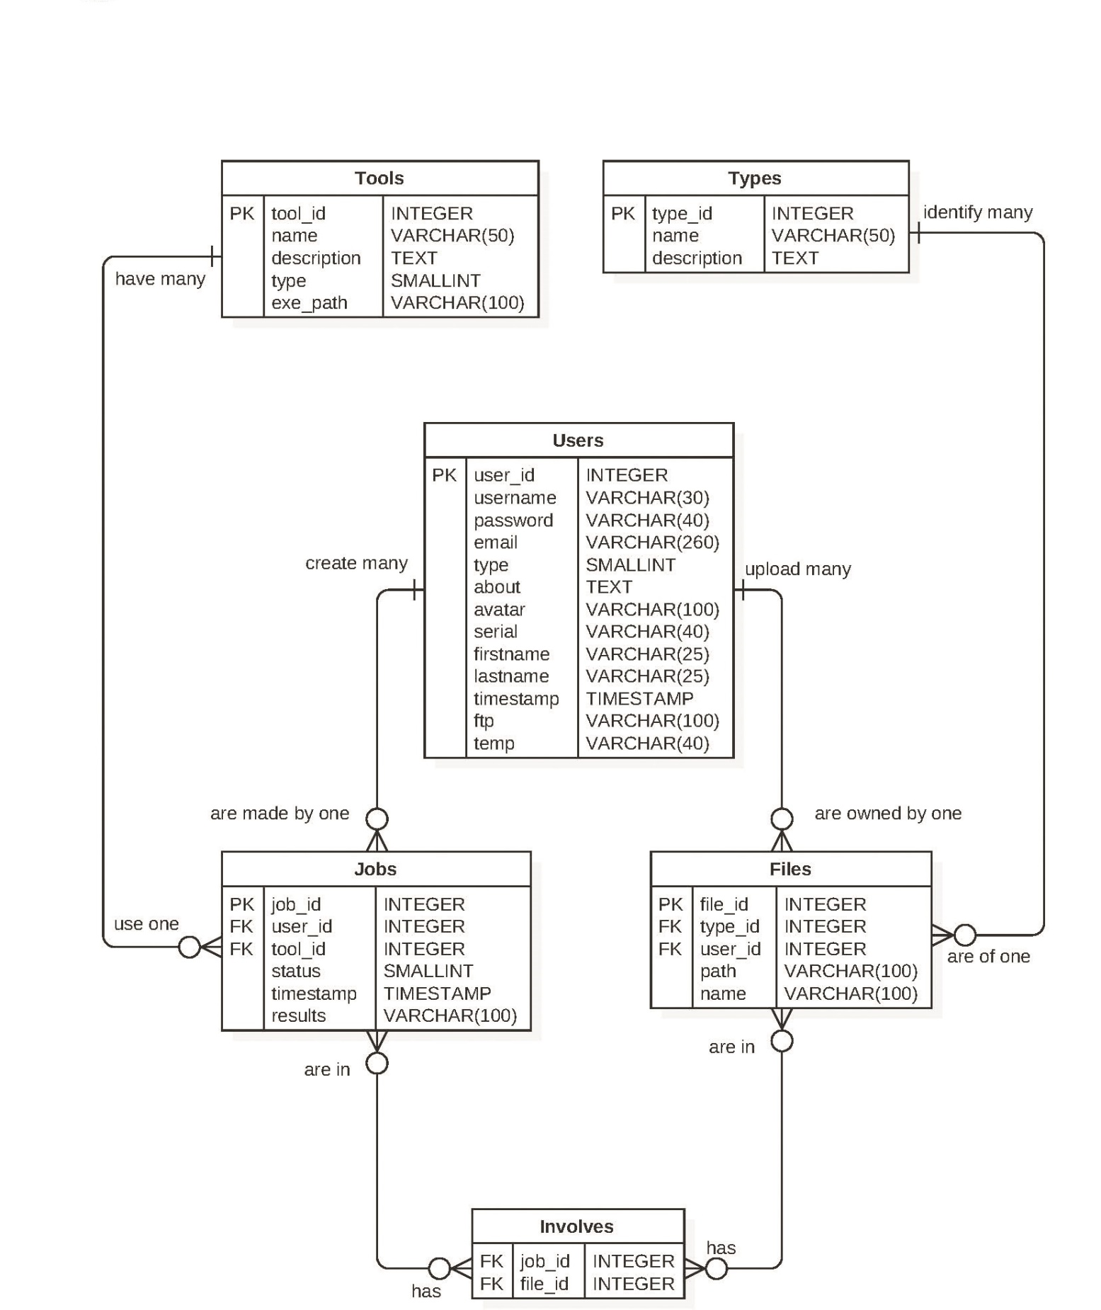

Figure - Database Modeling Diagram

#### *Classes Diagrams*

##### *Model-Controller Diagram 1*

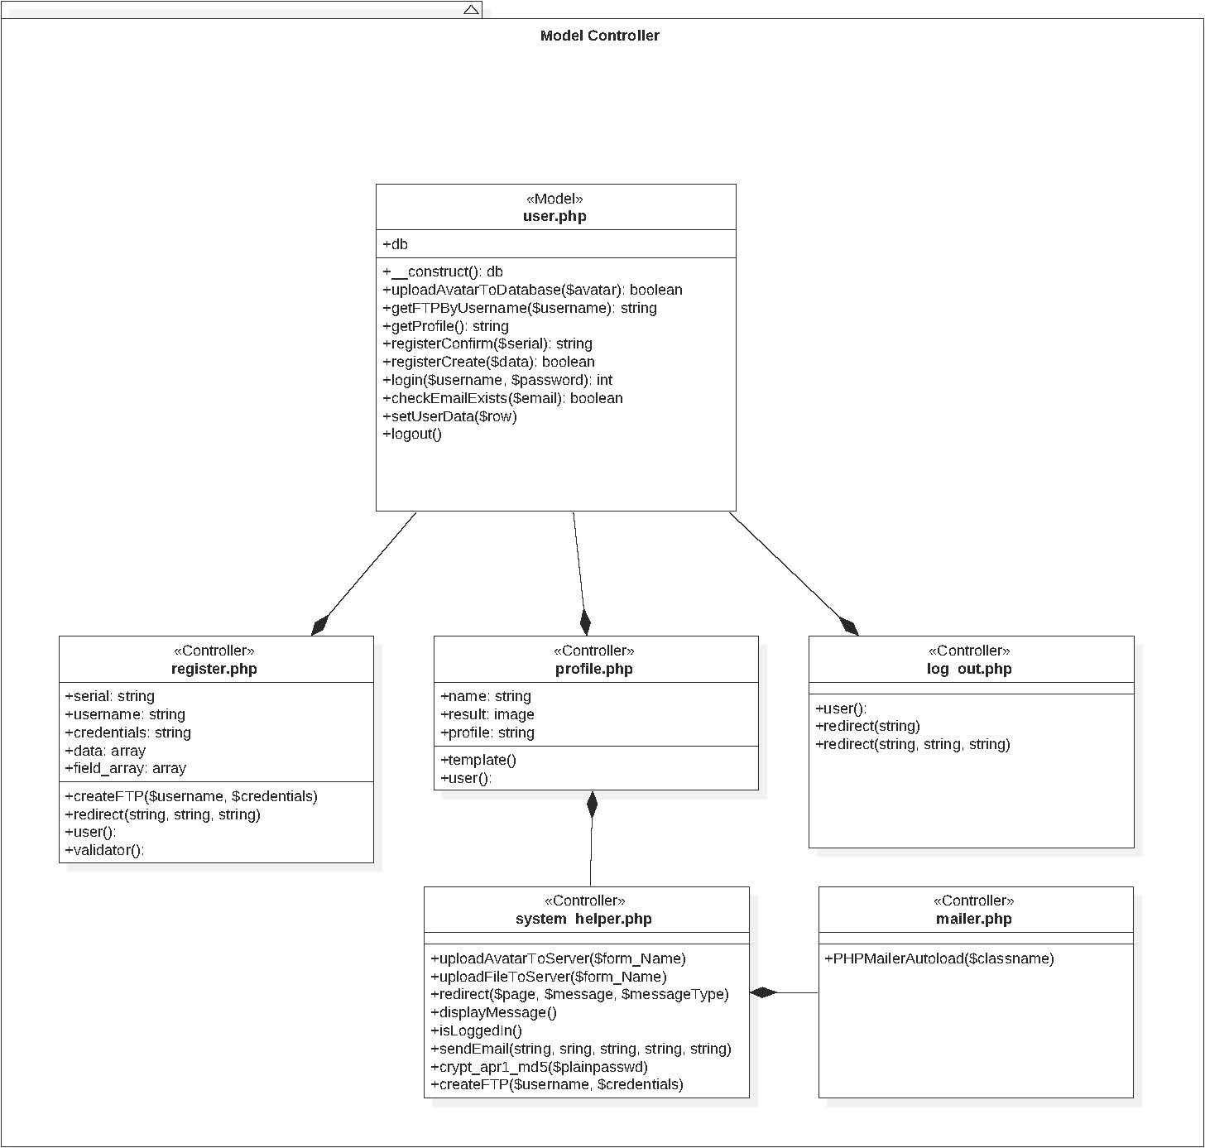

Figure – Model-Controller Diagram 1

##### *Model-Controller Diagram 2*

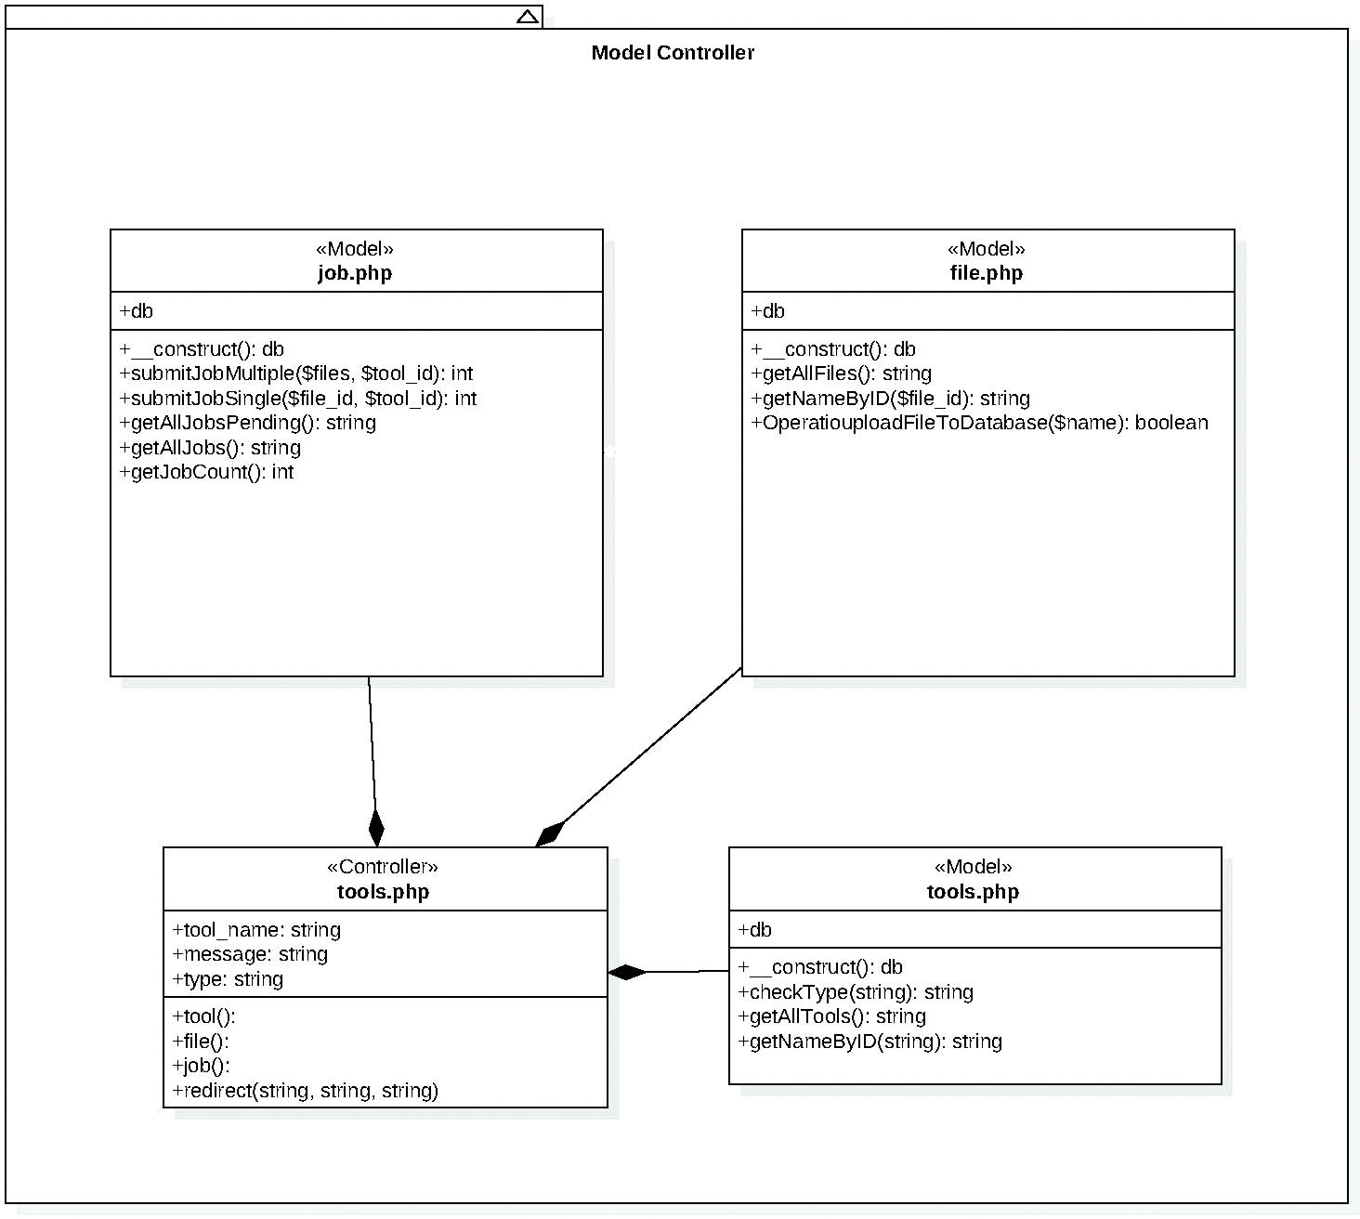

Figure – Model-Controller Diagram

##### *Model-Controller Diagram 3*

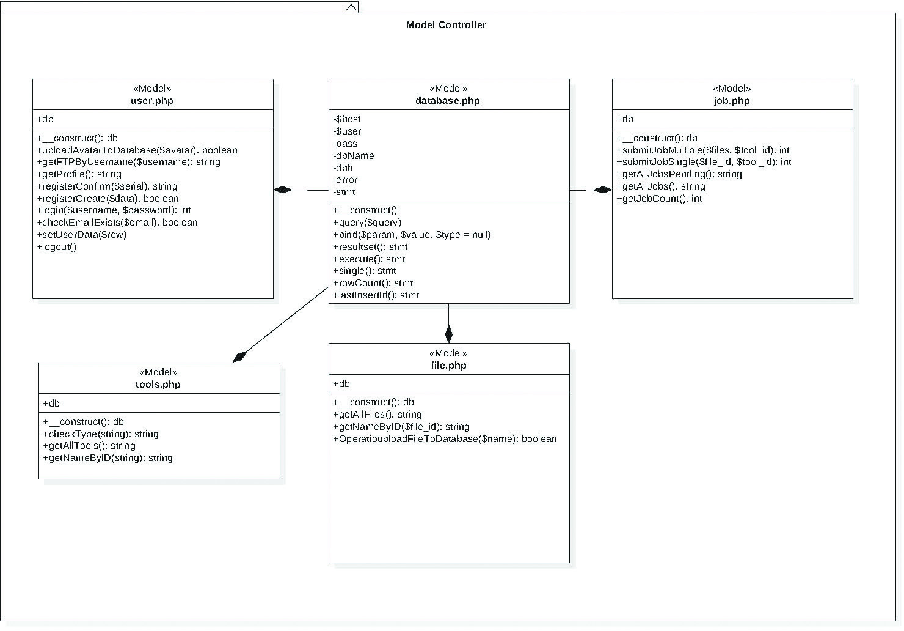

Figure – Model-Controller Diagram 3

##### *View-Controller Diagram 1*

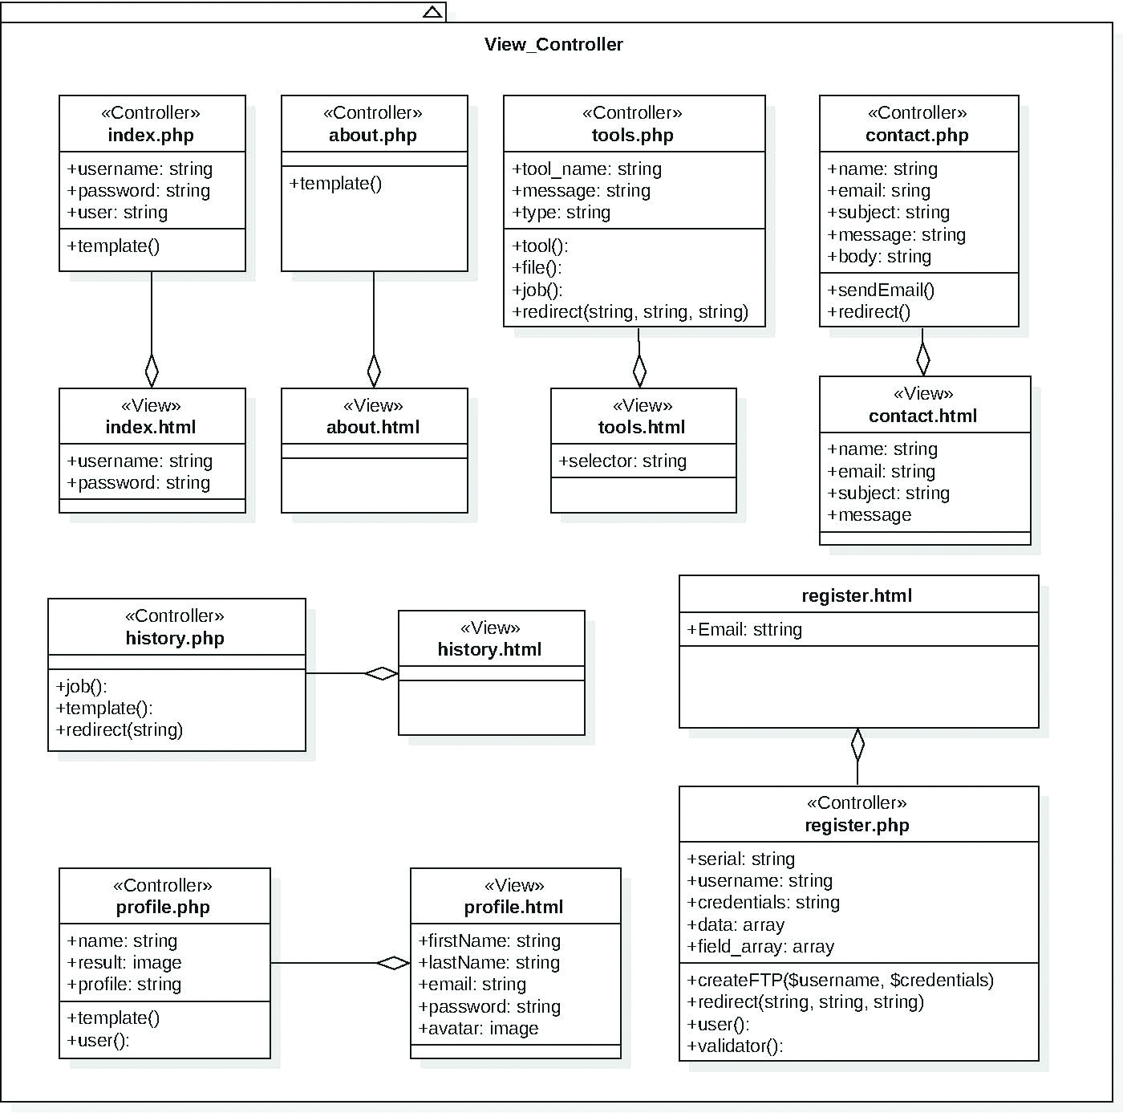

Figure – View-Controller Diagram 1

##### *View-Controller Diagram 2*

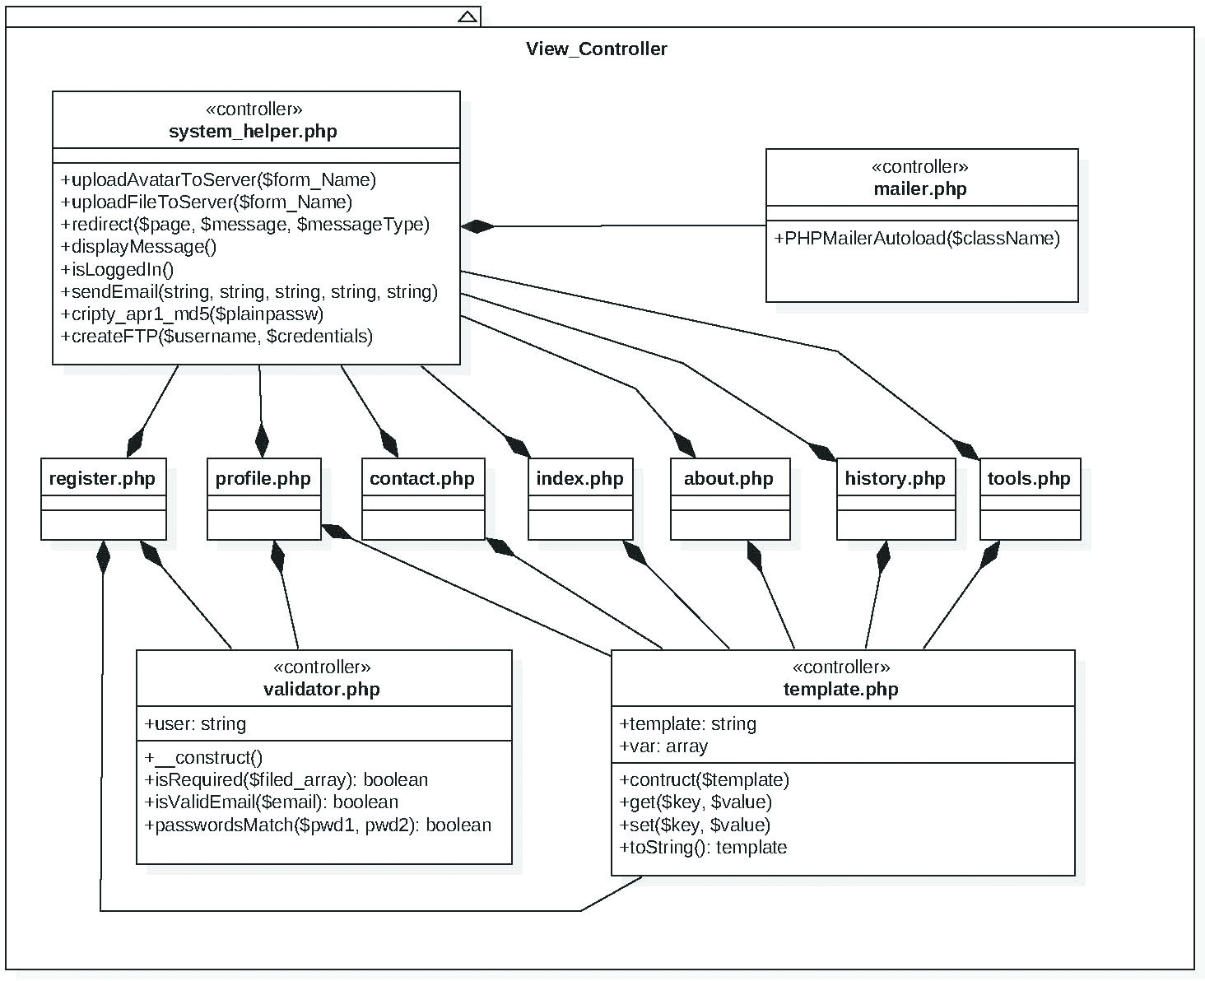

Figure – View-Controller Diagram 2

### Dynamic UML Diagrams

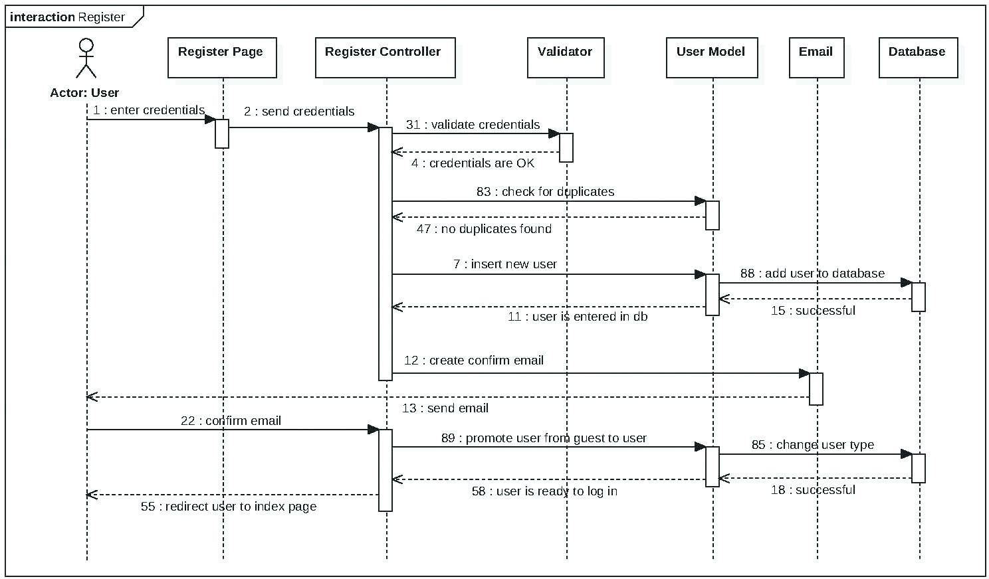

Figure – Register Sequence Diagram

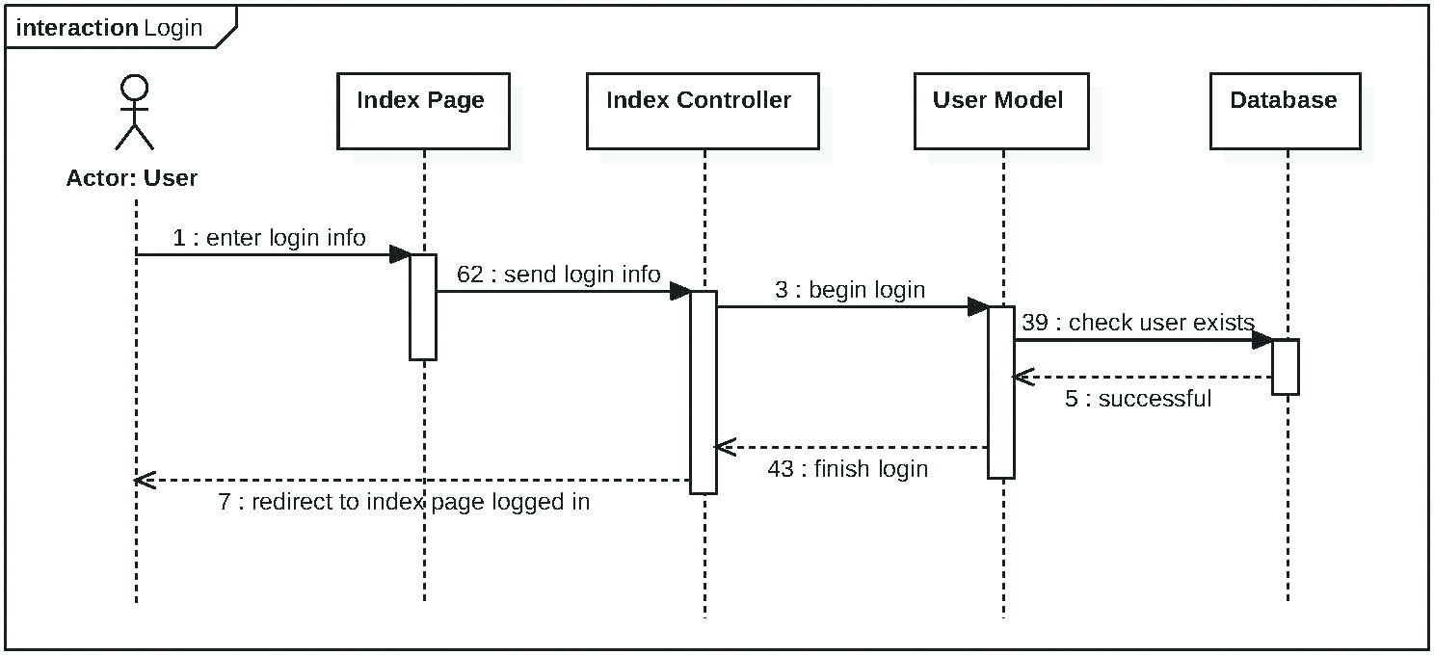

Figure – Login Sequence Diagram

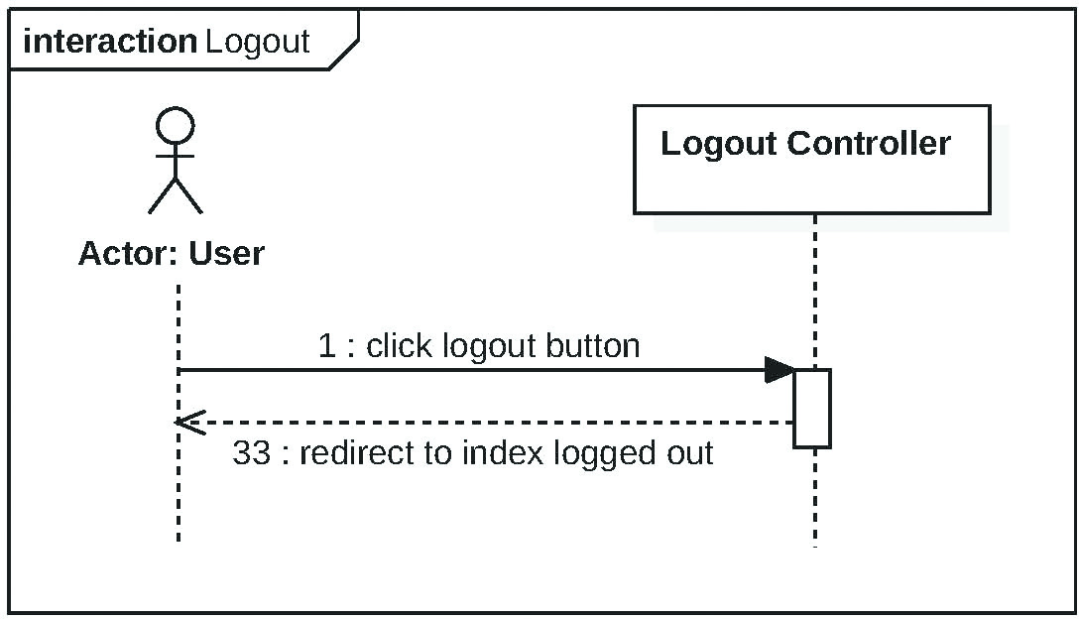

Figure – Logout Sequence Diagram

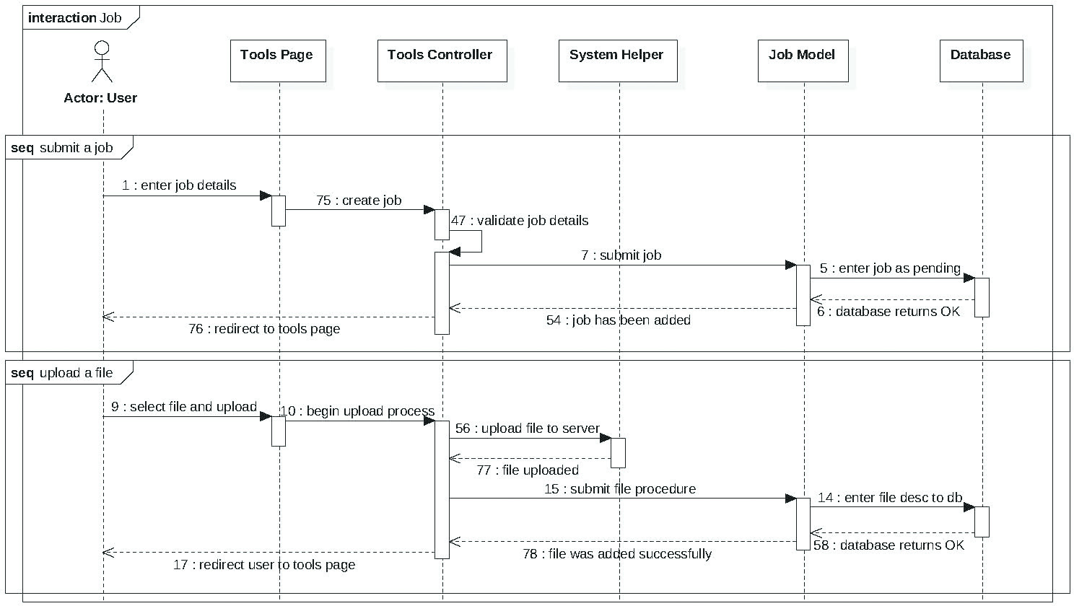

Figure – Job Sequence Diagram

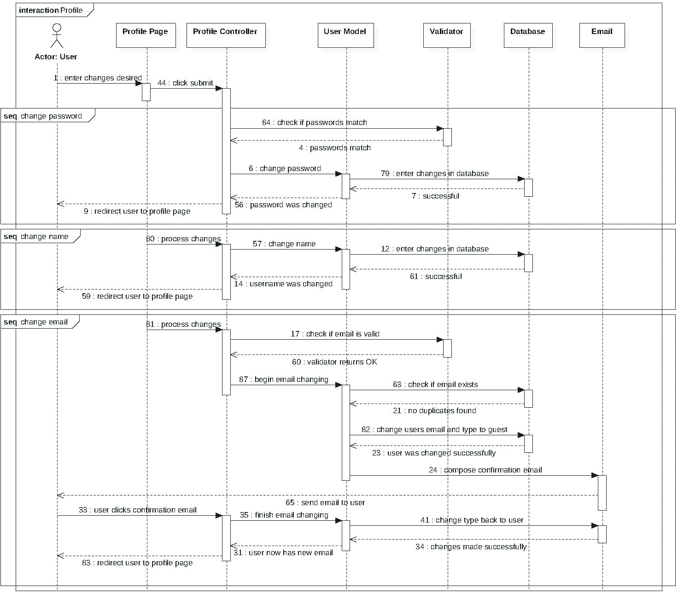

Figure – Profile Sequence Diagram

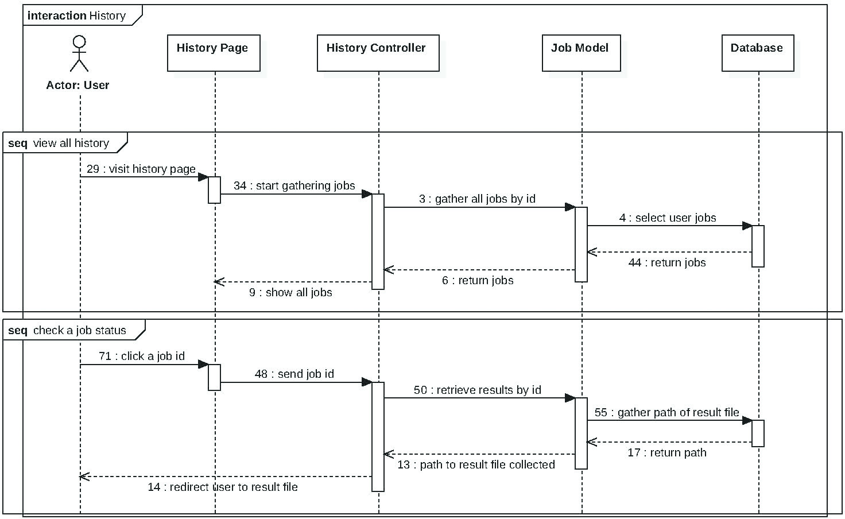

Figure – History Sequence Diagram

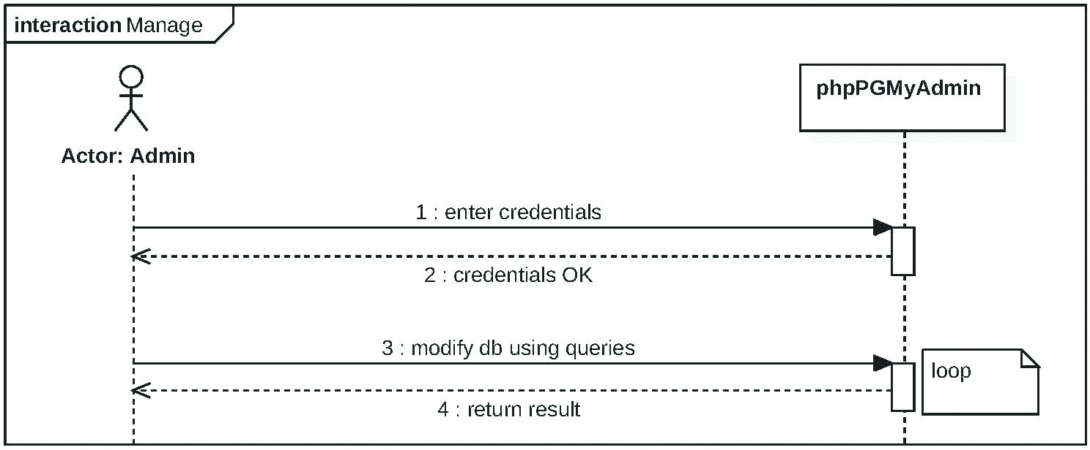

Figure – Manage Sequence Diagram

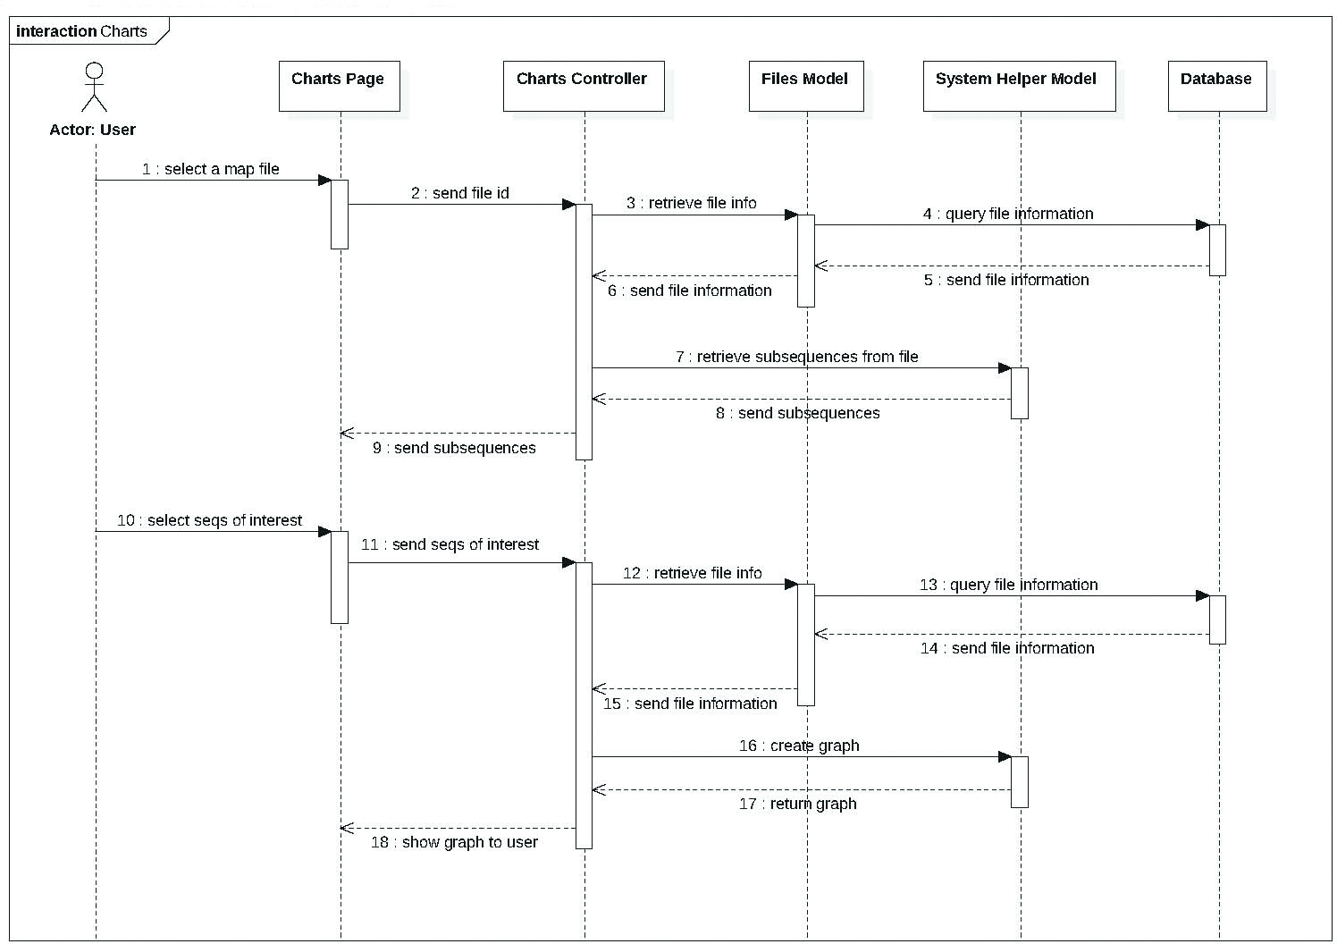

Figure – Create Charts Sequence Diagrams

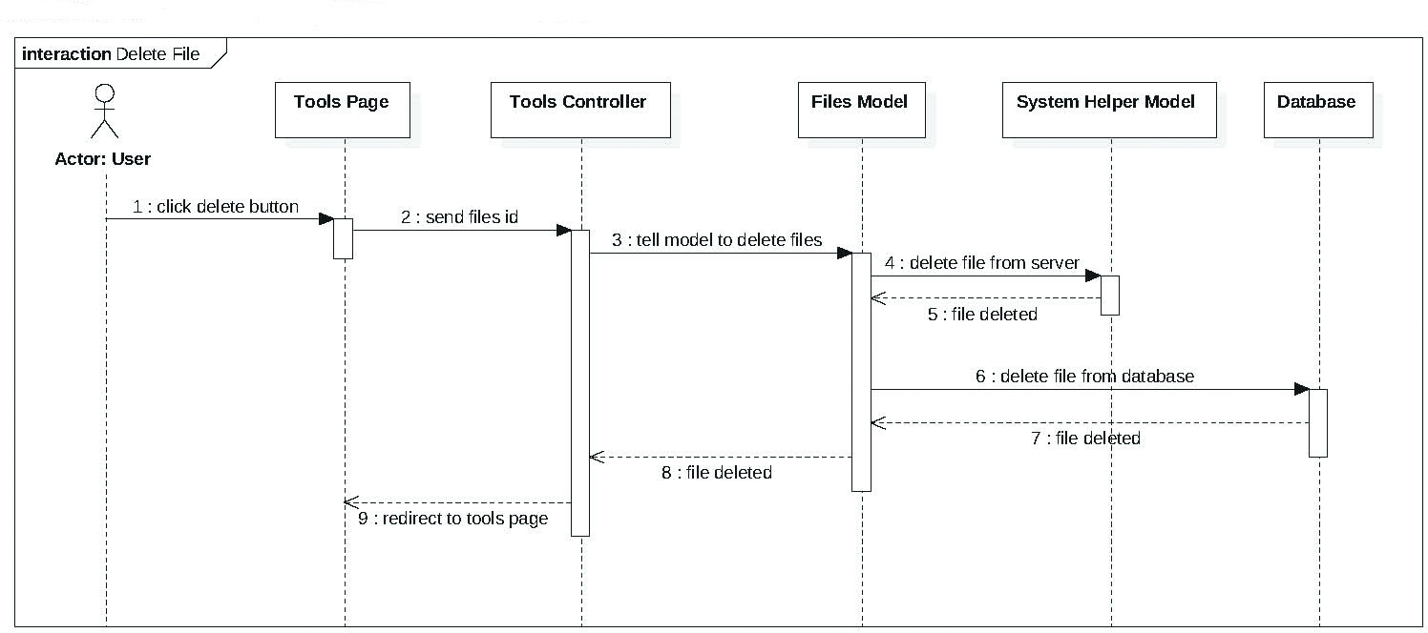

Figure - Delete File Sequence Diagram - Words go here...

## Appendix B - User Interface Design

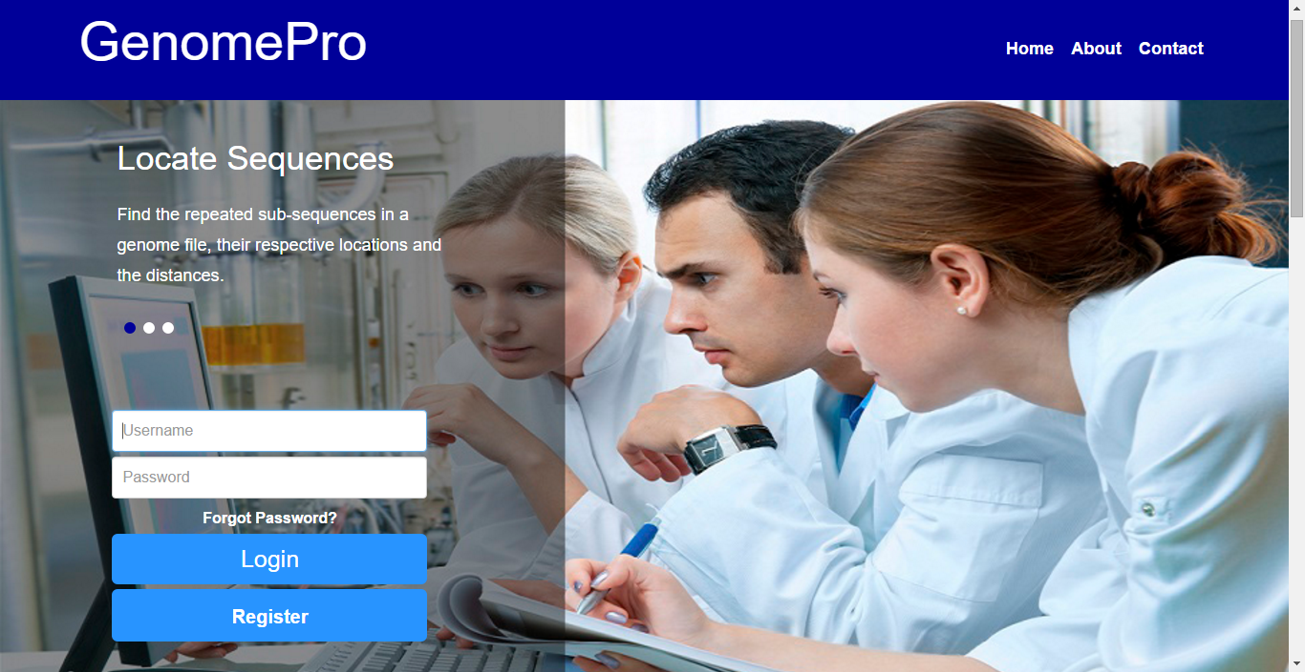

Figure - Home Page Login Area

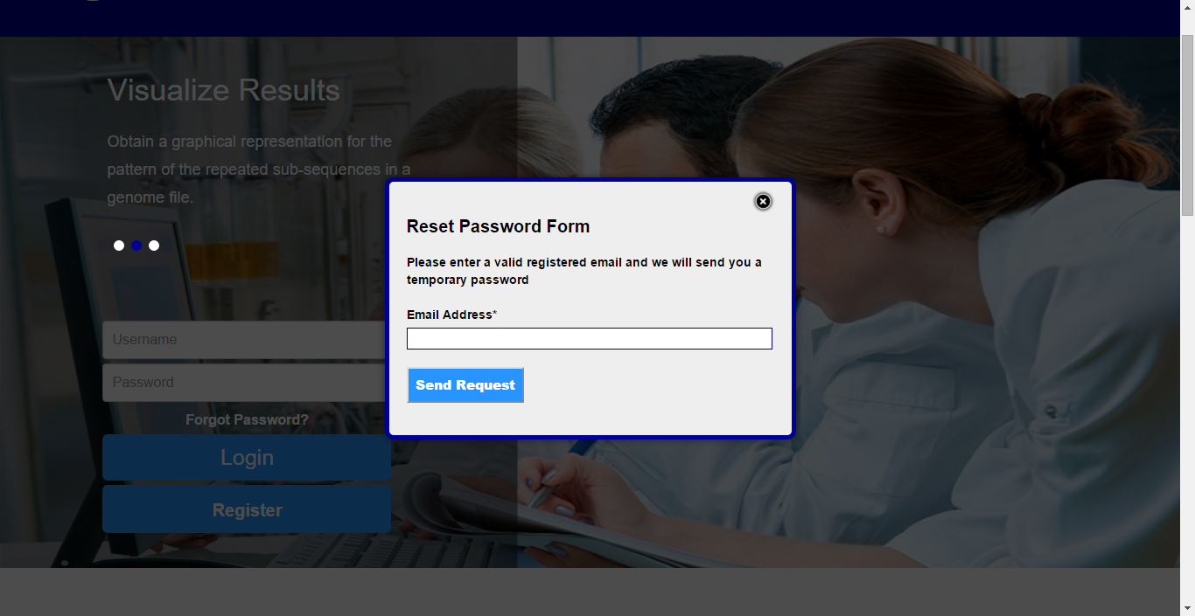

Figure - Home Page - Forget Password Feature

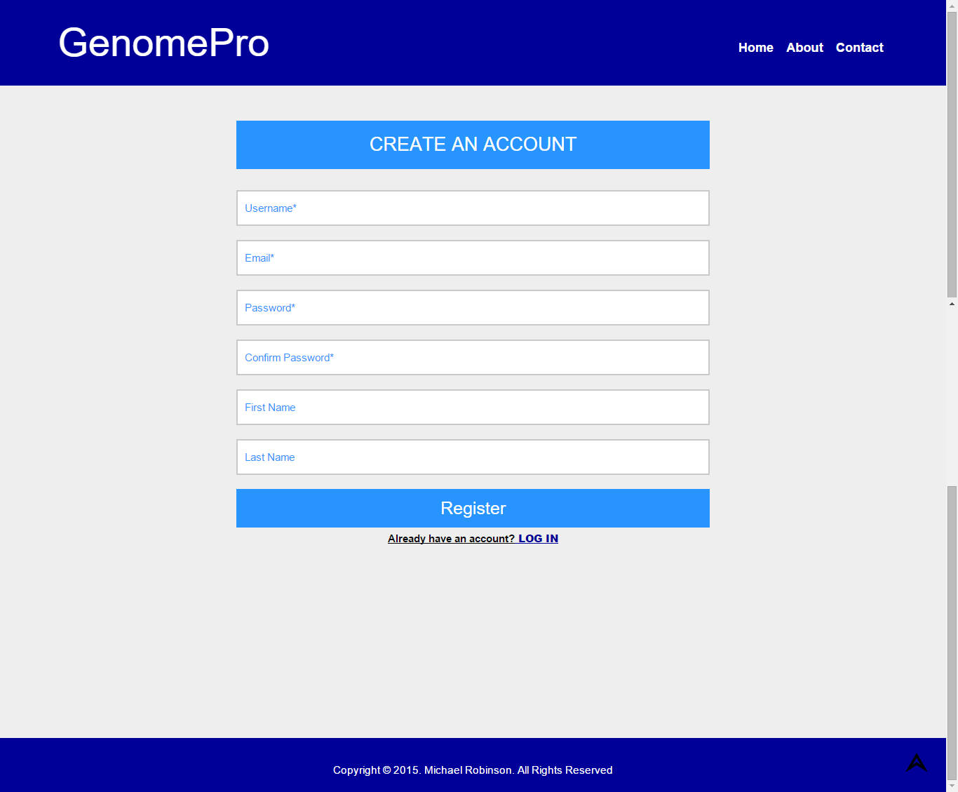

Figure - Register Page

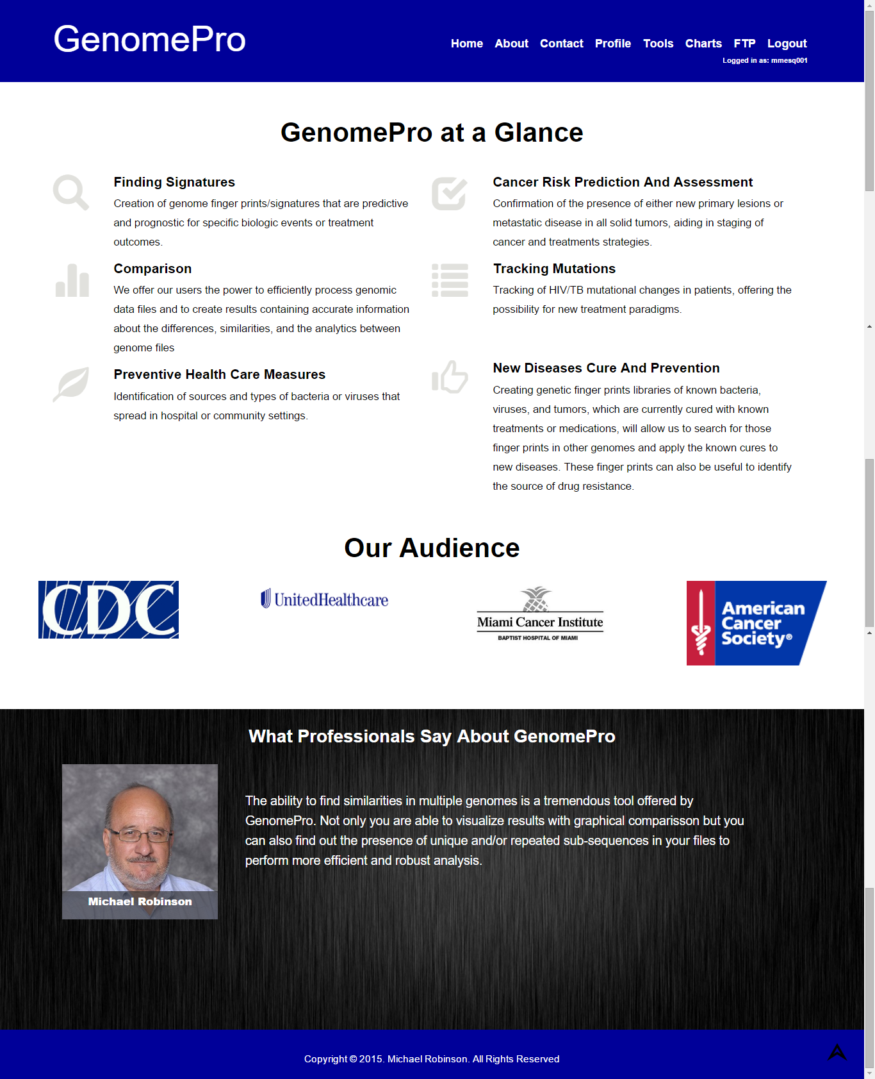

Figure - Home Page for Logged In Users

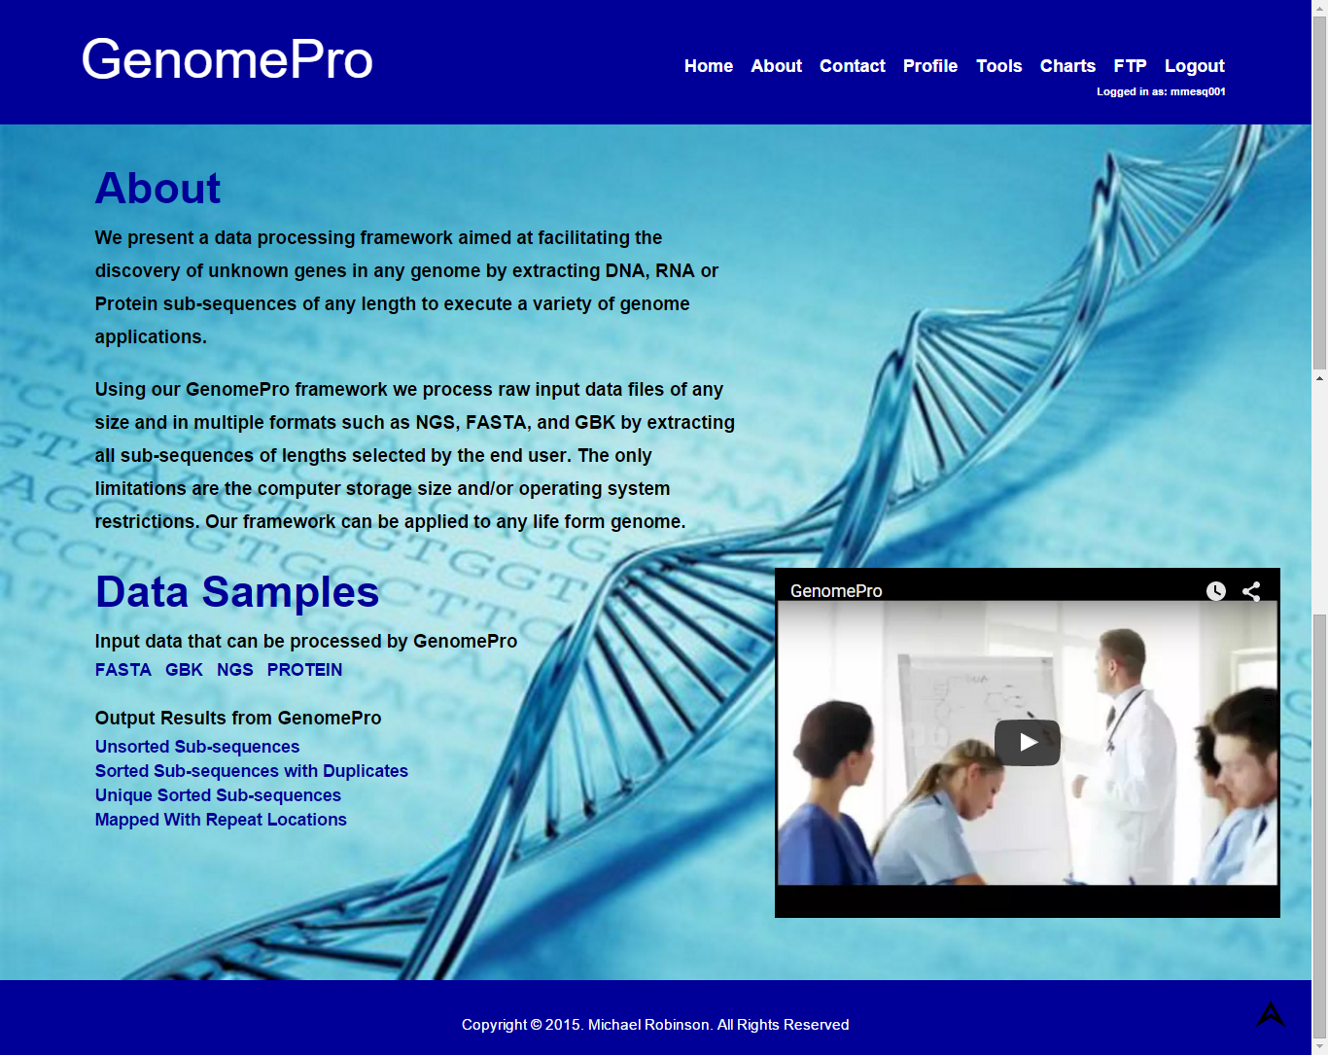

Figure - About Page

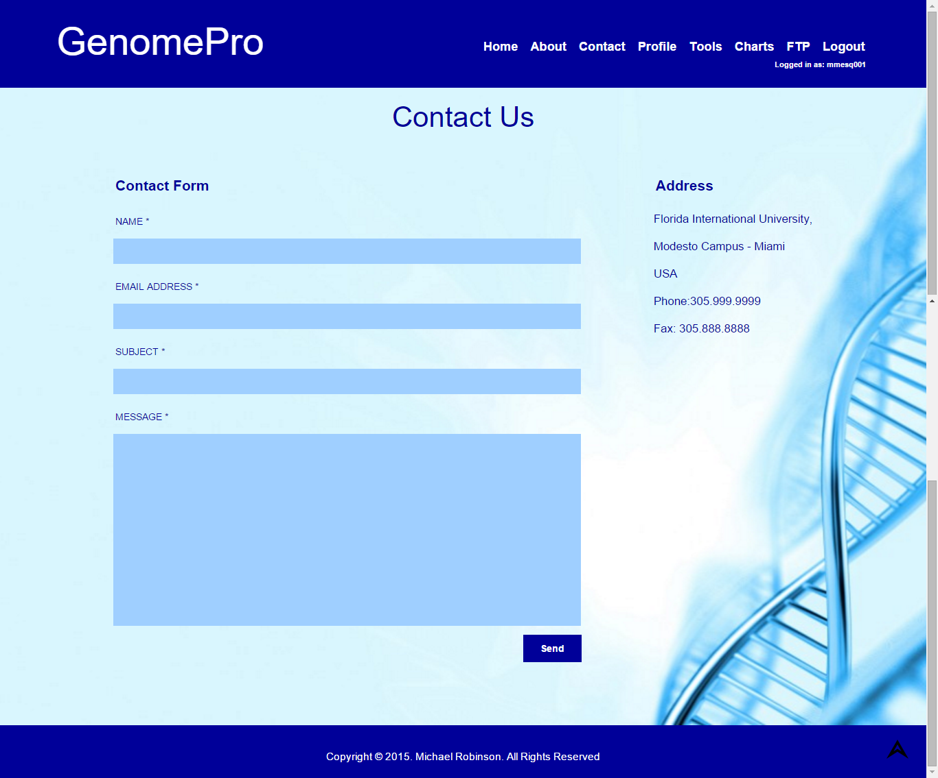

Figure - Contact Page

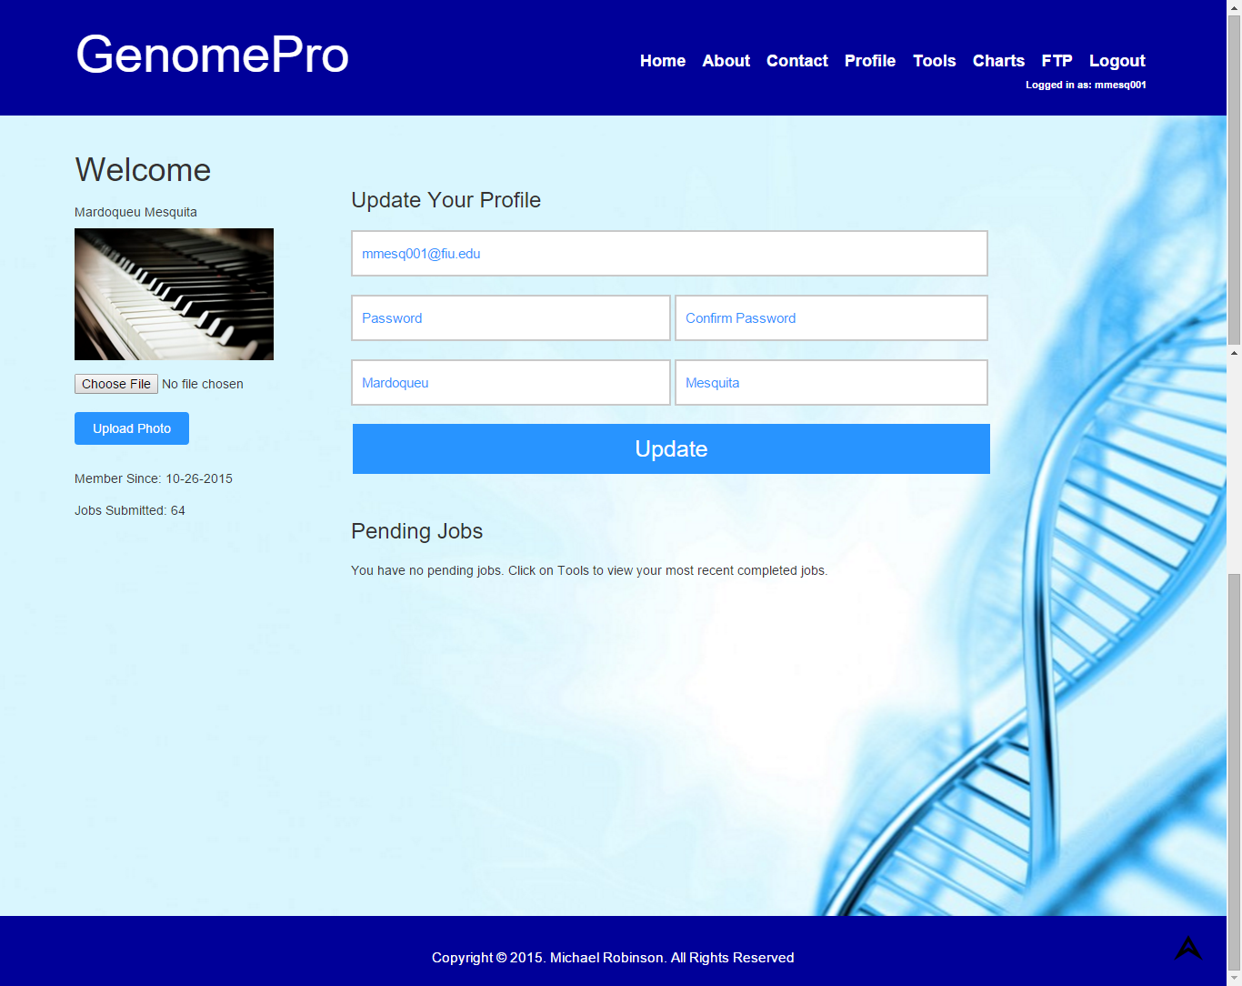

Figure - Profile Page for Logged In Users

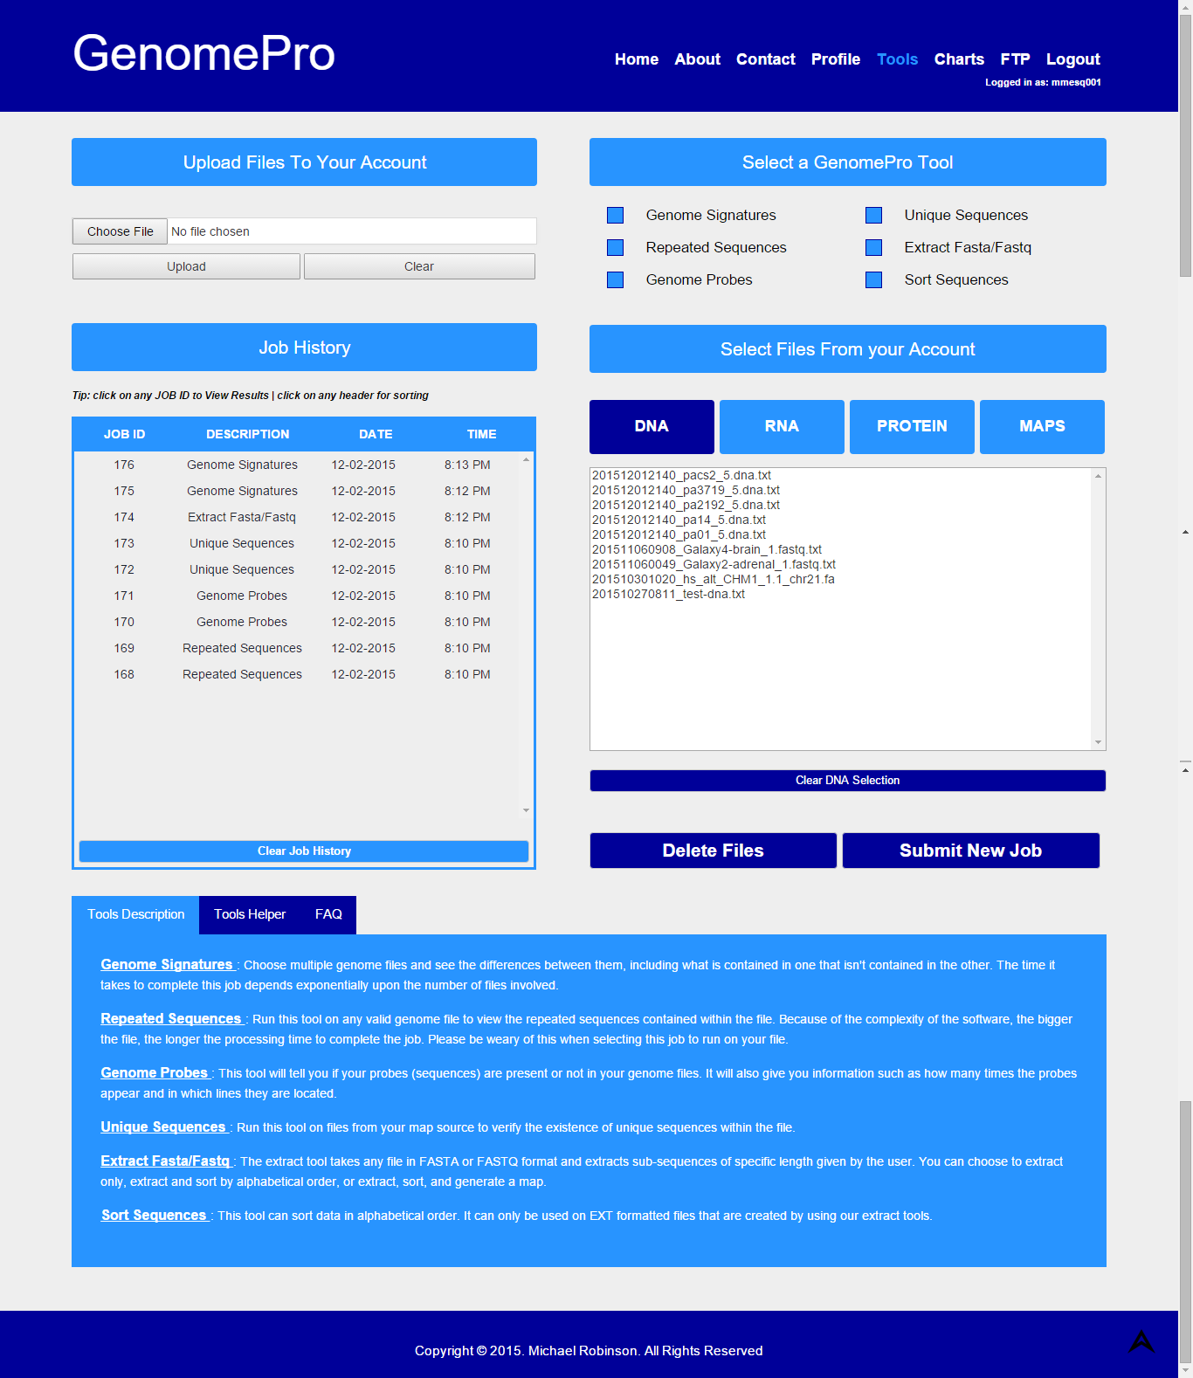

Figure - Tools Page for logged in users

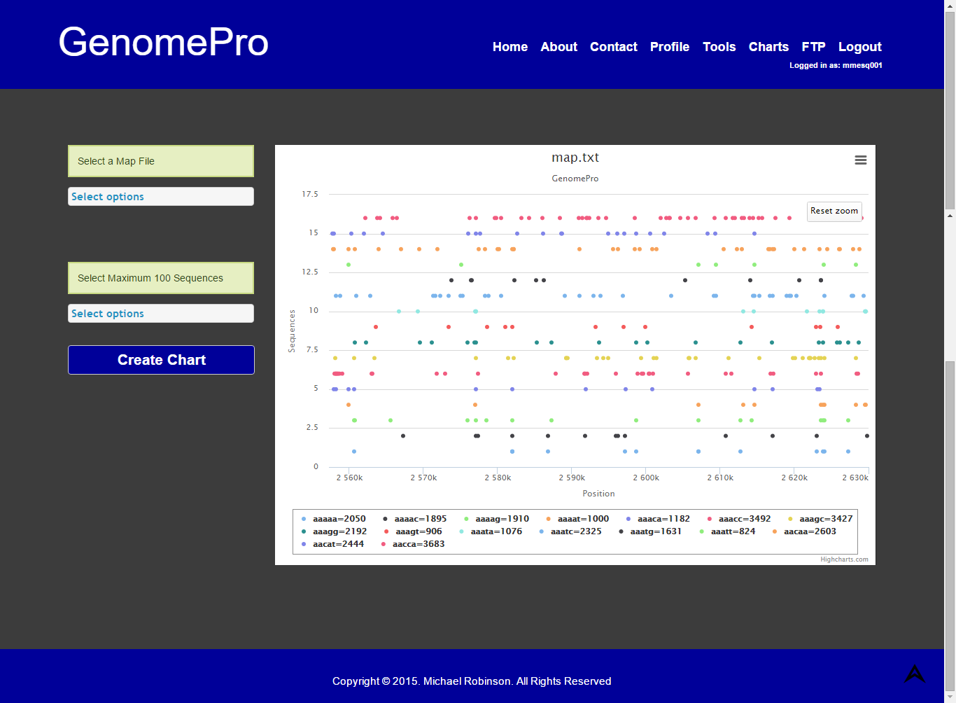

Figure - Charts Page for logged in users

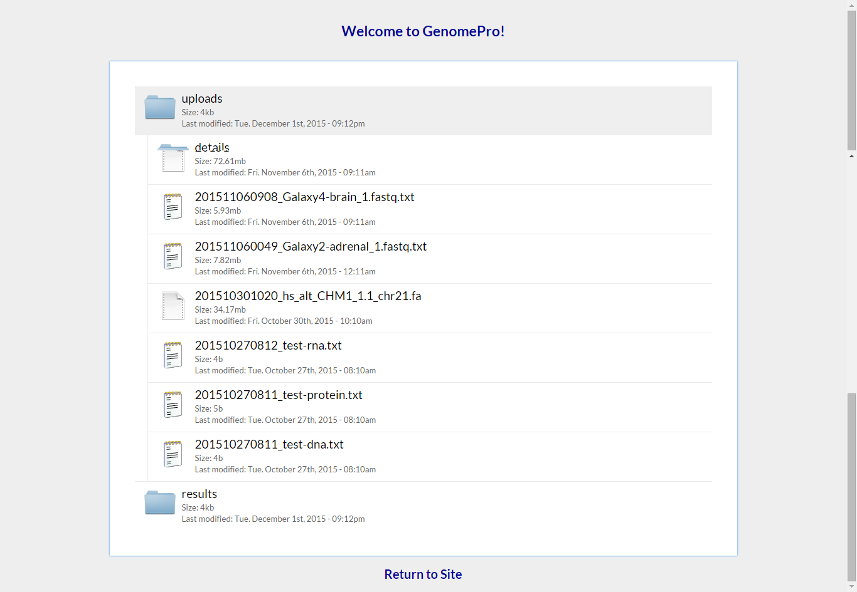

Figure - FTP Page for logged In Users

## Appendix C - Sprint Review Reports

### Sprint 1 Report

**Date:** September 11, 2015

**Attendees:** Guido Ruiz, Michael Robinson, Masoud Sadjadi

**Discussed Topics:**

The collection of the product backlog was definitely a game changer from the starting point. The team needed to remove unwanted software in the GenomePro 1.0, e.g. Bootstraps and Java programs, as one of the main requirements from the product owner. By removing those software features, serious implications on the previous design took place which led the team to brainstorm a complete new web design for the system, free of Bootstraps framework. In addition, the database schema and modeling had also to be changed to fit the needs of the new system architecture in such a way that new programs and tools could be thereunto implemented. Nevertheless, the team was able to completely redesign the web pages of GenomePro, reconstruct database modeling as well as new design patterns that allow for future changes when necessary.

### Sprint 2 Report

**Date:** September 25, 2015

**Attendees:** Guido Ruiz, Mardoqueu Mesquita, Michael Robinson, Masoud Sadjadi

**Discussed Topics:**

Sprint 2 was considered successful in the sense that both the product owner and instructor were satisfied with the outcome of this sprint release. Topics discussed involved the new flow of the web page as well as new functionalities and features. The UML diagrams were received with satisfaction. Business value was added in the form of improved marketability of website and definitely with the new FTP server feature that was built inside the current server thus avoiding possible financial overhead in the form of FTP server fees. Another topic pointed out by the instructor, Professor Sadjadi, was the absence of ongoing project documentation at which topic we moved towards the compilation of all project documents into the Final Deliverable.

### Sprint 3 Report

**Date:** October 09, 2015

**Attendees:** Guido Ruiz, Mardoqueu Mesquita, Michael Robinson, Mohsen Taheri

**Discussed Topics:**

In Sprint 3 the team was able to deliver new features such as a complete working FTP server with file navigation. The team was able to show the uploading and validation of files with successful messages being sent the user. The team also showed the chron job functionality that collects files from uploads and send them to be validated. The validator.exe was written in ANSI C as per the product owner requirement and is working according to the given specifications. The team was also able to show test cases for several user stories. The compilation of project documentation has been initiated.

### Sprint 4 Report

**Date:** October 23, 2015

**Attendees:** Guido Ruiz, Mardoqueu Mesquita, Michael Robinson, Masoud Sadjadi

**Discussed Topics:**

In Sprint 4 the team was able to keep up with speed for project delivering a good sprint release. The was able to show case new features such as the new redesigned tools page offering a more intuitive and user friendly web interface for the GenomePro tools. The validator.exe now delivers results in .txt format which are saved in the users ftp folders. The password recovery was implemented and is working according to its acceptance criteria. The team was able to show the compiled project documentation for the final deliverable.

### Sprint 5 Report

**Date:** November 06, 2015

**Attendees:** Guido Ruiz, Mardoqueu Mesquita, Michael Robinson, Masoud Sadjadi

**Discussed Topics:**

The delivery of Sprint 5 was a successful milestone and served to assure the team is on the path to the desire outcome for the project. The team was able to implement a graphical visualization of mapped genome data from sub-sequences of different lengths. That is in fact a great business value added to the website since it facilitates a better analysis over the appearance and location of those sequences. With this new feature, users can make comparison and predictions over such data. Another accomplishment was the implementation and integration of a new tool, namely the Extract FASTA/FASTQ tool along with a more intuitive web interface. Also, the FTP web interface was improved to facilitate a more natural navigation over directories and files. In addition, users can now delete any of their uploaded files. The project documentation was also updated to reflect changes in the website, e.g. sequence diagrams, use cases and user stories. Overall, the team feels on track towards the delivery of the Senior Project.

### Sprint 6 Report

**Date:** November 20, 2015

**Attendees:** Guido Ruiz, Mardoqueu Mesquita, Michael Robinson, Masoud Sadjadi

**Discussed Topics:**

Sprint 6 was delivered with success and the team continues on track to finish the project. Both the product owner and the instructor were satisfied with the sprint release. The team implemented two new tools, namely the Repeated Sequences and the Unique Sequences tools. Another added feature is that now users can view/download their files by double clicking a specific file. Also, users can now deselect options in the file selection so that no files are submitted incorrectly. In addition, the team worked on media queries to improve the website responsiveness on mobile devices. The project documentation was also updated to reflect changes, e.g. deployment diagrams. Overall, the team stays on track towards the rendition of final deliverable.

### Sprint 7 Report

**Date:** December 04, 2015

**Attendees:** Guido Ruiz, Mardoqueu Mesquita, Michael Robinson, Masoud Sadjadi

**Discussed Topics:**

This is the final sprint and team was able to deliver it successfully. New features were added, namely the results to upload feature, where files generated from one tool are now used as input for other tools. Another feature is that now users can clear their job history on the tools page, although this functionality does not delete jobs from database but only cleans the user’s view (history tab). More media queries were added to support screens of size 1920px, 1680px, 1600px, 1366px, 1280px, 1152px, 1080px, 1024px and for iPads 1 & 2. The file validator that runs with upload files now runs as a job and the result is also shown on the history tab. Professor Masoud instructed the team to halt all development activities and start working on final week activities posted on moodle. The team feels confident to deliver the senior project in its completeness.

## Appendix D - Sprint Retrospective Reports

### Sprint 1 Retrospective

**Date:** September 14, 2015

**Attendees:** Guido Ruiz, Mardoqueu Mesquita, Michael Robinson

**Discussed Topics:**

Although the team had a good sprint release presented to the product owner, some complications had negative impact on this release. Mardoqueu was absent due to his pre-scheduled work meeting and there were some technical issues during the conference disallowing Guido to present the website and features to the instructor. We were required to add business value to the system in which terms we collected more information from the product owner. Overall, we were called to upscale the next sprint presentation in order to deliver a good sprint release and to put the Team in track and alongside with the Senior Project Requirements.

### Sprint 2 Retrospective

**Date:** September 28, 2015

**Attendees:** Guido Ruiz, Mardoqueu Mesquita, Michael Robinson

**Discussed Topics:**

Sprint 2 had a successful release and the Team moves forward to the sprint planning for sprint 3. We discussed the need to create a GUI for FTP for allowing users to manage all their files in a better and more intuitive fashion. We did a follow up over Professor Sadjadi’s request to present project documentation and the Team committed to start compilation of all documents into the ongoing Final Deliverable. Overall the Team felt in track with all requirement to proceed towards the completion of the Senior Project.

### Sprint 3 Retrospective

**Date:** October 12, 2015

**Attendees:** Guido Ruiz, Mardoqueu Mesquita, Michael Robinson

**Discussed Topics:**

The release of Sprint 3 was successful and the team moves forward into planning for Sprint 4. We realized the need to modify some C programs created by the product owner in order to integrate main functionalities for the website such as the ones offered as GenomePro tools. These modifications are required since programs now need to receive input arguments from the users. The team also realizes the need to start planning and working towards delivering graphic representation for the GenomePro tool’s results.

### Sprint 4 Retrospective

**Date:** October 26, 2015

**Attendees:** Guido Ruiz, Mardoqueu Mesquita, Michael Robinson

**Discussed Topics:**

The sprint release was very successful even though the team had one user story transferred to Sprint 5, namely user story #245. The FTP page now works with a new web interface with parent directories. The team has been working diligently to deliver complete sprint releases and is confident that the final product will surpass the product owner expectations. The web interface to support graphs was not implemented during this sprint, so now the team works on researching available tools for graphical representation of large amount of data. Overall, the team feels confident with the Senior Project requirements and is on track with the project’s development.

### Sprint 5 Retrospective

**Date:** November 09, 2015

**Attendees:** Guido Ruiz, Mardoqueu Mesquita, Michael Robinson

**Discussed Topics:**

During this release the team absorbed user stories that were pushed from Sprint 4 and were successfully implemented along with the added user stories collected for sprint 5. The team feels the need to finalize website responsiveness for the remaining sprints but before the final sprint. We now move towards a new goal which is to recycle files created as a result of particular job processing, e.g. maps and signatures, so that that it can also be used serve as input for the user to choose when selecting other tools such as probes and unique sequences. It was also pointed out that there is a need for a promo video to be added into the about page. Another topic mentioned was to elaborate and look for a solution for the issue on downloading the charts into PDF, JPG or PNG files. The team stays on track for the completion of Senior Project.

### Sprint 6 Retrospective

**Date:** November 23, 2015

**Attendees:** Guido Ruiz, Mardoqueu Mesquita, Michael Robinson

**Discussed Topics:**

The release of sprint 6 was successful and now the team moves towards the last sprint and final presentation. There were two main topics mentioned during the retrospective meeting: Implementation of new options for the extract tool; namely: sort and maps and the addition of results from tools to file selection. The team also agrees to work on finalizing all aspects of the project prior to next Sprint Review in order to not leave any task undone. The need to add media queries for tablets, e.g. iPad 1 & 2 was also mentioned. The team stays on track for the completion of the Senior Project.

### Sprint 7 Retrospective

**Date:** December 04, 2015

**Attendees:** Guido Ruiz, Mardoqueu Mesquita, Michael Robinson

**Discussed Topics:**

Sprint 7 was successfully released. The team now has to plan accordingly for the final week of activities as scheduled by the instructor. It is valid to note that Michael Robison stated that the outcome of the project exceeded his expectations.